An Investigation into Active Compliant Control of Brushless DC Robotic Actuators using Matlab®/Simulink® and NI LabView® With SoftMotion®

Dominic C. L. McKean

August 2017

In Partial Fulfilment for the Degree of Bachelor

of Science in Electrical & Electronic Engineering

At Loughborough College/University of Derby

1st Supervisor: Dr Muhammed Al-Asadi, Loughborough College

Industrial Supervisor: Dr Thomas Steffen, Loughborough University

Independent Engineering Project (Engineering) Module Code 6TE500

# PLAGIARISM STATEMENT

I certify that this assignment/report is my own work, based on my personal

study and/or research and that I have acknowledged all material and sources

used in its preparation, whether they be books, articles, reports, lecture notes,

and any other kind of document, electronic or personal communication. I also

certify that this assignment/report has not previously been submitted for

assessment in any other unit, except where specific permission has been granted

from all unit coordinators involved, or at any other time in this unit, and that I

have not copied in part or whole or otherwise plagiarised the work of other

students and/or persons.

Name D McKean Date 16.08.2017

Signature

# Abstract

Compliant control has been a steadily increasing technology since the 1980s. The idea of robots and humans being able to work together in safety has been a goal of many roboticists and recently there has been a huge surge in the number of robotic manufacturers developing compliant robotic systems for safe human robot collaboration. This report considered some of these compliant control strategies and tested their appropriateness for use with National Instrument’s Softmotion Control together with National Instrument’s LabView graphical programming language, as it was believed compliant control had not yet been realised using this software. The report also considered appropriate hardware provided by national instruments, namely the Kollmorgen BLDC servo motor and drive and investigated the limitation of this hardware with respect to compliant control. The report also looked at whether the control strategies could be incorporated into the control architecture of an electrically assisted turbocharger for future turbo modelling research and reduced carbon emissions.

Initial testing provided very promising results and clearly demonstrated that compliant control was possible using the named hardware and software. Impedance, admittance and a hybrid control strategy were all implemented successfully. Investigations into control bandwidth found an interesting relationship between the motor’s magnetic field and the torque sensitivity of the system. It is thought that a magnetic field ripple around the motor’s poles may produce a corresponding holding-torque ripple with varies the motor’s sensitivity to external forces such as gravity creating slight variations in torque up to about 0.05Nm.

# Acknowledgements

The author would like to thank the following people for their much needed help and support, especially during very difficult times.

My industrial advisor; Dr. Thomas Steffen for first suggesting this project to me and believing I could accomplish it, despite it being at MSc level.

Proff. Richard Stobart for the lending of his very expensive National Instruments hardware.

Dr. Matt Parker for his patient assistance with LabView programming,

Dr. Zhijia Yang for her help with control systems and continuous encouragement.

Dr. Byron Mason and

Proff. Kambiz Ebrahimi for their continued help and encouragement.

Rob Flint for all his help with software and licencing problems.

And to my long suffering family which has gone from three to five members during this time. Lara, William, James and Alice, thank you for being so patient with me over the last six years of my degree. You have given so much and demanded so little.

# Contents

I. PLAGIARISM STATEMENT 2

II. Abstract 3

III. Acknowledgements 4

IV. Contents 5

V. List of Figures 8

VI. List of Tables 11

VII. Nomenclature 12

VIII. Forward by Author 13

1. Chapter 1, Project Overview 14

1.1. Introduction 14

1.2. Aims and Objectives 16

1.3. Report Structure 17

2. Chapter 2, literature Review 19

2.1. Review of Turbocharges Machinery 19

2.2. Basic Feedback Control 21

2.3. Active Compliant Control, A Critical Review of Current Literature 22

2.4. Impedance & Admittance Control Strategies 25

3. Chapter 3, Proposed Hardware and Software Development 31

3.1. Selection of Innovation Techniques 32

3.2. Technique 1 - Challenge Assumptions 35

3.2.1. Table of Assumptions 35

3.2.2. Critique of ‘Challenge Assumptions’ Technique 36

3.3. Technique 2 – The lotus Blossom Technique 37

3.3.1. Completed Lotus Blossom 37

3.3.2. Critique of ‘Lotus Blossom’ Technique 38

3.4. Technique 3 – Random Input 40

3.4.1. Random Input Words 40

3.4.2. Analysis and Critique of ‘Random Input’ Technique 40

3.5. Technique 4 - Wishing 42

3.5.1. The Wishing Table 42

3.5.2. Critique of ‘Wishing’ Technique 42

3.6. Critical Evaluation of Techniques Used 43

3.7. Investigation into Brushless DC Motors for Compliant Control 44

3.8. Control of BLDC Motors 47

4. Chapter 4, System Modelling 51

4.1. Motor Modelling 51

4.2. Electric Motor modelling 53

4.3. Actuator Modelling 55

4.4. Actuator Modelling Using Lagrangian Mechanics 57

4.5. Implementing Lagrangian Mechanics on A 1DoF Rotating Actuator 60

4.5.1. Expansion of the Inertia 62

4.5.2. Friction 63

4.6. PID Control 64

4.7. Impedance Modelling 67

4.8. Modelling Environmental Interaction 68

4.9. Timing Function 69

4.10. Gravity Compensation 71

4.11. Simulation Results 73

4.12. Discussions 79

4.5. Chapter Conclusion & Recommendations for Further Work 80

5. Chapter 5, Physical Implementation of The New Control Algorithm 81

5.1. Physical Setup 81

5.2. User Interface 88

5.3. Force Measurement 90

5.4. System Testing Methodology 92

5.5. Initial test Results 93

5.6. How the Compliant Algorithm Was Expected to Work 94

5.7. Hypothesis as to Why the Compliant Algorithm Did Not Work 95

5.8. Triumph! How Compliance Can Be Created using NI LabView With SoftMotion 95

5.9. Gravity Compensation 98

5.10. Problems Incorporating Gravity Compensation 100

5.11. Impedance Control Finalisation 101

5.12. Admittance Control 103

5.13. Hybrid Compliance 106

5.14. A Discussion on The Compliant Control of Conventional & Electrically Assisted Turbocharges 109

5.15. Compliant Control for Electrically Assisted Turbocharges for Increased Efficiency 111

5.16. Implementation of a Possible Compliant Turbo Control 112

5.17. Limitations of Compliant Control 115

6. Chapter 6, Conclusion, A Review of What Has Been Achieved Plus Future Applications and Further Possible Work 116

6.1.1. Impedance Controlled Turbocharger 116

6.1.2. Human Robot Collaboration 117

7. Appendix I, Personal Reflection on Report 118

8. Appendix II. Further Attempts at Gravity Compensation 120

9. Appendix III, MS Project Gantt Chart 121

10. Appendix IV, Previous LabView Code from Early Attempts at compliant code 122

11. Appendix V, Kollmorgen AKM24 Servo Motor Technical Specification 126

12. Appendix VI References 129

13. Appendix VII, REVISION OF PROJECT EXPENDITURE FORM 133

14. Appendix VIII, INDUSTRIAL SUPERVISORS FORM 134

# List of Figures

Figure 2.1, control system block diagram. (Abdallah & Kennedy, 2013) 21

Figure 2.2, Block diagram shows back drivability by control. (Calanca, et al., 2016) 28

Figure 2.3, Block diagram of admittance control scheme (Calanca, et al., 2016) 28

Figure 2.4, Block diagram of impedance control scheme (Calanca, et al., 2016) 30

Figure 3.1, Selecting Appropriate Techniques. The rows highlighted in red indicate techniques appropriate for the given problem. 33

Figure 3.2, Table of assumptions about system design. 35

Figure 3.3, Lotus Blossom Brainstorming Technique, Matsumura. 37

Figure 3.4, Lotus Blossom Technique 38

Figure 3.5, Wishing Table 42

Figure 3.6, Table of ideas from innovation tools. 43

Figure 3.7, In-runner BLDC Motor, TI.com 2017 45

Figure 3.8, Out-runner BLDC Motor, DroneTrest.com 2014 45

Figure 3.9 BLDC power supply/control system. Microchip 47

Figure 3.10, Hall sensor and coil excitation. Digikey.com 2013 48

Figure 3.11, Diagram showing phase nots connected by neutral wire loop. DigitalPimple 2012 48

Figure 3.12, 3 coil pairs in series Wye configuration 49

Figure 3.13, 12 pole rotor wiring configuration. DigitalPimple 2012 49

Figure 3.14, Trapezoidal back emf of a three phases BLDC motor. S. Rambabu 2007 50

Figure 4.1, Equivalent circuit of a simple DC motor armature and free body diagram of the rotor. (Prof. Messner & prof. Tilbury, n.d.) 51

Figure 4.2, Block diagram of DC motor in Simulink® 54

Figure 4.3, Free Body Diagram of actuator 55

Figure 4.4, Actuator Assembly for This Project. 56

Figure 4.5, Lagrange, (1736-1813) 57

Figure 4.6, Simulink model of the opposing force acting on the motor. D. McKean 2017 62

Figure 4.7, Motor and actuator model with gravitational, frictional and inertial dynamics incorporated. 63

Figure 4.8, Step response of basic DC motor with manually tuned integral controller 65

Figure 4.9, Matlab PID Tuner, Matlab® 2016a 66

Figure 4.10 The controller block showing the Impedance, Admittance and PID functions 67

Figure 4.11 Environmental Subsystem plus Timing Function 69

Figure 4.12, Full system model in Simulink ® 70

Figure 4.13, Chart showing sin of angle in blue and sin of gravity torque in yellow. D. McKean 2017 71

Figure 4.14, Gravity Comp chart. D. McKean 2017 72

Figure 4.15, Gravity comp chart. D. McKean 2017 72

Figure 4.16, Block diagram showing an attempt at adding in gravity compensation to block diagram. D. McKean 2017 72

Figure 4.17 Graph showing the pause in angle displacement (Red) & reduction in actuator velocity (Blue) during an environmental impact at time t=1s to t=2s. Gains: K=2, d=6 ke=2 de=2 73

Figure 4.18, Graph showing the exogenous force feedback in green. 74

Figure 4.19, Controller reacting to the dynamics of the unloaded system. 75

Figure 4.20, Graph showing environmental impact with high actuator stiffness gain. k=10 d=6 ke=2 de=2 76

Figure 4.21, Graph showing unstable operation @ k=50 d=6 ke=2 de=2. 77

Figure 4.22, k=7 d=6 ke=2 de=2. 78

Figure 4.23, Graph shows the effect of an underdamped system gain. k=3 d=3 ke=10 de=10 78

Figure 4.24, Bode plot of the open loop actuator. 79

Figure 5.1, Proposed actuator and loadcell setup. D. McKean 2017 81

Figure 5.2, Turning up a boss on the lath. D. McKean 2017 83

Figure 5.3, Mounting boss. D. McKean 2017 83

Figure 5.4 Calibrating the zero degree point on the motor, D. McKean 2017 84

Figure 5.5 Picture of Actuator Assembly, D. McKean 2016 85

Figure 5.6 Kollmorgen AKD Servo Drive, D. McKean 2016 86

Figure 5.7 Compact Rio Assembly, D. McKean 2016 87

Figure 5.8 LabView GUI designed by the author. D. McKean 2017 88

Figure 5.9, Load Cell, D. McKean 2016 90

Figure 5.10, New torsional load cell attached between two members forming a new robot arm. D. McKean 2017 91

Figure 5.11, Video of the author validating the motor actuator set up prior to adding the compliant control algorithm. 92

Figure 5.12, Initial LabView code, D. McKean 2017. 93

Figure 5.13, Close up of LabView code showing a compliant control algorithm. D. McKean 2017 94

Figure 5.14, Close up view of new working compliant control algorithm in LabView. D. McKean 2017 95

Figure 5.15, Video demonstrating the working compliant control algorithm and a Kollmorgen servo motor using NI LabView SoftMotion. D. McKean 2017 96

Figure 5.16, LabView code showing gravity compensation, D McKean 2017 99

Figure 5.17, 12 poles of the BLDC motor out by 15 degrees relative 100

Figure 5.18 LabView code for completed impedance controller. D. McKean 2017 101

Figure 5.19, Admittance controller LabView code, D. McKean 2017 104

Figure 5.20, Video showing admittance controller. D. McKean 2017 105

Figure 5.21, LabView code for the Hybrid Controller. D. McKean 2017 106

Figure 5.22, LabView GUI for hybrid controller. D. McKean 2017 107

Figure 5.23, Video showing the new hybrid controller in operation. D. McKean 2017 108

Figure 5.24, Shows robot arm meeting an environmental object. D. McKean 2017 108

Figure 5.25, Servomotor with disc fitted. D. McKean 2017. 112

Figure 5.26, Compliance code for turbo model. D. McKean 2017 113

Figure 5.27, Video of Admittance controlled disc representing a turbocharger. D. McKean 2017 114

Figure 5.28, Showing the use of a surgical haptic device. DLR 2017 115

Figure 8.1, Attempting to fix gravity compensation problem in Simulink model. D. McKean 2017 120

Figure 8.2, Gravity compensation using torque feedback from motor. D. McKean 120

Figure 9.1, Project Gantt Chart of Compliant Control project. D. McKean 2017 121

Figure 9.2, Gantt Chart of Compliant Control Project. D. McKean 2017 121

Figure 10.1, Impedance Control code 1, D. McKean 2017 122

Figure 10.2Impedance control code 2, D. McKean 2017 123

Figure 10.3, Impedance control code 3, D. McKean 2017 123

Figure 10.4, Impedance control code 4, D. McKean 2017 124

Figure 10.5, Impedance control 5, D. McKean 2017 125

Figure 10.6, LabView project, D. McKean 2017 125

# List of Tables

Table 3.1, Selecting Appropriate Techniques. The rows highlighted in red indicate techniques appropriate for the given problem. 33

Table 3.2 Table of assumptions about system design 35

Table 3.3, Lotus Blossom Technique 38

Table 3.4, Wishing Table 42

Table 3.5, Table of ideas from innovation tools. 43

Table 4.1, Table of simple DC motor parameters 52

Table 11.1, Part 1 of Kollmorgen AKM24 datasheet (Kollmorgen, 2014) 127

Table 11.2, Part 2 of Kollmorgen AKM24 Datasheet (Kollmorgen, 2014) 128

# Nomenclature

|  |  |
| --- | --- |
| $$u$$ | Input |
| $$y$$ | Output |
| $$t$$ | Time |
| $$V$$ | Voltage |
| $$i$$ | Current |
| $$R$$ | Resistance |
| Q | Charge |
| $$T$$ | Torque |
| θ | Angular displacement |
| $$I$$ | Mass moment of inertia |
| $$m$$ | Mass |
| $$g$$ | Gravity constant = 9.81 $m/\sec^{2}$ |
| $$h$$ | Height |
| $$l$$ | Length |
| $$ψ$$ | Euler-Lagrange model |
| $$k$$ | Stiffness |
| $$d$$ | Damping |
| $$L$$ | Lagrange equation |
| $$E$$ | Energy |
| $$K$$ | Constant or Stiffness depending on context |
| $$s$$ | Laplace operator |
| DoF | Degree of freedom |
|  |  |

# Forward by Author

The general topic of this final year project is control systems. It is believed that to be a great engineer, it is important to have a good understanding of all forms of engineering and science to be able to see how different disciplines can work together to produce an engineered system. Being able to control electromechanical systems well, requires a good understanding of how all the pieces fit and work together and an ability to foresee problems that may arise and quickly find solutions to systems if not thought out correctly. Controls is an area that may be regarded as difficult by some and indeed it is to begin with as there are many new concepts that may need learning as prerequisites such as Lagrangian mechanics and Jocobian matrices, but it is these new concepts that make learning control systems exciting. Some of these new concepts are like walking through a wardrobe to find a new world you never knew existed, a new way of thinking about the world around you and how everything is made up of springs, masses and dampers all interacting with each other. The author has had no prior learning of controls but seeing what can be achieved in the world of robotics has been a huge eye opener and this is what has sparked the interest and rational for this project. With no formal training in this area it is hoped that learning journey this project can offer will fill in the gaps in the understanding of how these sometimes very complicated robotic control systems can be realised, particularly the area of compliant robotics that will provide robots that everyone can safely work with in many areas of life. This will not be an easy journey and it is anticipated that there may be much better ways of achieving some of the goals set out in this project, but it is hoped that the reader is able to see the resourcefulness and ingenuity the author has used to solve many of the problems encountered to achieve very satisfactory results.

# Chapter 1, Project Overview

## Introduction

The purpose of this project will be twofold, although both goals are heavily interlinked. The first will be to research and implement an existing control strategy for the purpose of robotics control but to do so in a new way. Namely, using National Instruments LabView with ‘Softmotion’ control to produce a compliant robotic arm control strategy that is sensitive to touch, making it safe to work collaboratively with humans. Human robot collaboration is a very fast moving research area whose goal is to produce compliant robots that are completely safe for humans to not only work with in an industrial setting where most robots reside at present, but also able to physically assist a human through direct contact. Examples of such would be patient rehabilitation exoskeletons that are able to multiply the effort exerted upon them from the patient who may be recovering from a stroke or have a musculoskeletal condition that inhibits their ability to feely move themselves and interact with the world around them. (Yang, et al., 2006) Safe compliant control is a fundamental aspect of this type of human robot collaboration as no one wants a situation where the robotic suit could potentially harm the patient by driving the actuators and the patient’s limbs in directions they cannot move.

Secondly, the new control strategy will be turned towards the development of new electrically assisted turbocharges for the goal of low carbon engine emissions. Research being carried out on electrically assisted turbocharges by (Winward, et al., 2016) at Loughborough University is helping to increase the efficiency of internal combustion engines by electrically driving the turbo to overcome turbo lag problems and increase power where and when it is needed. Electrically assisted turbocharges also help increase efficiency by recovering otherwise lost kinetic energy from the turbo when extra power is not needed such as when the accelerator pedal is released. This recovered energy is then stored within the vehicle battery waiting to help spool the turbo for the next time the accelerator is pressed.

Producing turbocharges of any type is a costly enterprise, producing electric turbos is even more so. Computer modelling has played a large role in speeding up engineering design and manufacturing, but computer models can only take you so far in that there are always slight shortcomings in the algorithm due to oversimplification of the model or just not fully understanding the physics involved. Having an adaptable physical turbo employing a brushless DC motor which is capable of mimicking various sizes and geometries of turbo would be a better solution, as the hardware model could be fitted to the engine and extract real data in real time and gain a real understanding of the dynamics of the whole engine system.

Being able to control an electric motor and have it behave in this way is called a variety of things but in this context, it is referred to generally as compliant control, with sub categories namely impedance and admittance control depending on the design architecture used. Analogous to the impedance of electric circuits, mechanical impedance is the mechanism’s resistance to change or inertia. Using torque and position feedback from a motor, impedance control is able to change the apparent inertia or stiffness and damping of the motor and is most commonly used in the application of robotics for object manipulation, safe robot-human interaction and even rehabilitation exoskeletons (Hogan, 1985) (Yang, et al., 2006).

This thesis will look into how to best realise an experimental impedance controlled motor system that will demonstrate the capabilities of the control method in regards to turbocharges and investigate its limitations in terms of stability and bandwidth. A mathematical model of the system will first be implemented in Matlab®/Simulink® to create a controller topology which will then be deployed and tested on a physical 1 degree of freedom motor and actuator assembly before being tested on the real turbocharger.

## Aims and Objectives

The aims of this project are to devise a compliant control algorithm that can be employed onto a 1Dof robot arm that will allow safe robot human interaction and to also have the control strategy work on an existing electrically assisted turbocharger to help in the future modelling of new electrically assisted turbocharges by varying the apparent inertia of the system. The aims of this projects are to first;

* Review current literature regarding compliant control methods and see if any are suitable for use on an electric turbo.
* Develop a compliant control algorithm and system model in Simulink® for research and testing.
* Apply the new compliant control model to a physical actuator for verification and validation.
* Find the limitations of any compliant control algorithms developed.

## Report Structure

Chapter 1, Project Overview

This chapter as shown herein gives an overview of the project, the aims and objectives, proposed methodology and this, the report structure. The purpose of this chapter is to give the reader an intuitive feel for how the report is laid out and to help navigate to points of interest as quickly as possible.

Chapter 2, Literature Review

This chapter will give an overview of the main ideas expressed in this report. It will start with a brief literary of turbo machinery, control theory, robotic control and compliant control strategies. This chapter will also focus on developing the tools and knowledge needed to develop the control architecture explaining how it is relevant to developing algorithms for motor control. It quickly became apparent that learning control theory was needed in order to read and understand the content of most research papers and MSc/PhD thesis on control systems.

Chapter 3, Proposed Hardware

This chapter will focus on brainstorming and developing new ideas to help determine the most rational, productive and cost-effective method of researching and implementing compliant control. It will start by exploring a number of innovation techniques to help produce as many new ideas as possible and then try to determine the most appropriate. Towards the end of this chapter there will be an introduction to ‘Brushless DC’ (BLDC) motors as proposed hardware. The Electrically assisted turbocharger uses a BLDC motor to drive the turbo compressor and recover exhaust energy from the turbo turbine. Any developed control hardware will need to interface with this type of motor and be able to control the motor in its most basic fashion before applying an advanced control architecture. It was therefore deemed necessary to become familiar with BLDC motors, how they operate and how they provide feedback for their control.

Chapter 4, System Modelling

This chapter will detail with all of the system dynamics required to build a mathematical model of an electric motor and 1 degree of freedom actuator arm. This will include the system inertia, gravitational effects, friction and the dynamics of environmental collisions. This chapter will also give an introduction to Lagrangian mechanics. The report will then show how some of this newly acquired controls theory is put into practice by developing a simple DC motor model. This model will be used to develop the impedance control system in Simulink® and test the model for robustness.

Chapter 5, Physical Implementation

This chapter is the physical implementation of the compliant control strategies developed in chapter 4. It will go through the hardware setup, developing the compliant control code in LabView and a test of the results.

Chapters 6 through 9 are the appendices.

# Chapter 2, literature Review

## Review of Turbocharges Machinery

This research is ultimately tasked with producing a compliant control algorithm for used with an electrically assisted turbocharger and so a brief history of turbo machinery focusing on electrically assisted turbocharges will follow.

According to (BorgWarner, 2017) whom is the industrial partner on this and many other electrically assisted turbocharger projects being researched at Loughborough University, the history of turbocharging is almost as old as the internal combustion engine itself and Rudolf Diesel and Gottlieb Daimler in 1885 were the first to experiment with compressing an engine intake air charge using a gear driven air pump (Calais Turbo, 2017). However, Sir Dugald Clark’s 2srtoke engine patented in 1881 also used forced induction. It wasn’t until 1925 that the Swiss engineer Alfred Büchi invented his turbocharger utilising the waste exhaust gas to drive the turbo. The turbine of the turbo was attached via a shaft to an impeller that forced fresh air into the engine. This breakthrough increased the power output of the engine by 40% (BorgWarner, 2017) and began the slow but steady introduction of forced induction engines, first on very large marine engines, then on aviation engine, large trucks and eventually in 1962 on family sized automobiles such as the Chevrolet Corvair. (Terbolader.net, 2017) Throughout the 1960’s and early 70’s high manufacturing costs and poor reliability meant that turbocharging was just not cost effective, that was until the oil crisis of 1973 sparked a renewed appreciation for the fuel saving abilities of the turbocharger. Also during the 1980’s, government environmental legislation started to force automotive manufacturers to produce greener vehicles, especially commercial diesels vehicles and eventually all passenger diesels vehicles. During the 1990’s, Passenger gasoline vehicles were improved by the introduction of electronic fuel injection (EFI) which was much more efficient and reliable for reducing harmful exhaust emissions and improving fuel economy. However, as environmental legislation gets stricter the gasoline turbocharged engine is making a comeback. In fact, a great deal of work on the award-winning Ford ‘Ecoboost’ family of engines is currently being done in the Engines and Powertrains Research facility at Loughborough University. The latest idea behind turbocharging gasoline engines is ‘downsizing’. By adding a turbo to a gasoline engine, the engine itself can be downsized while maintaining the same performance characteristics. This means a turboed 1 litre, 3-cylinder Ford Ecoboost engine is able to give the same power output as the equivalent 1.6 litre engine and at the same time dramatically reducing the fuel consumption and exhaust emissions. The turbos used on these engines are electrically operated ‘waste gate’ turbos, which means that when there is excessive intake air pressure detected by the intake manifold absolute pressure (MAP) sensor, exhaust gas in the exhaust manifold is bypassed around the turbo’s turbine into the main exhaust. This has the effect of allowing the turbo to slow down reducing the amount of air being forced in. These turbos are also relatively small which due to their low inertia allows them to spool up much quicker overcoming the dreaded ‘turbo lag’ which is characterised by a usually small but noticeable delay in a turboed vehicle’s ability to pull away quickly.

Another type of turbocharge being developed at the Engines and Powertrains Facility is the ‘Electrically Assisted Turbocharger’. This new electric turbo looks very much like a conventional turbo but with an electric motor fitted in between the turbine and the compressor. The idea behind the electric turbo is to provide additional power at low engine revs when the engine is not yet

## Basic Feedback Control

In order to fully appreciate the complexities of compliant control, a review of control systems was necessary. This is the section that originally sparked the interest in this subject matter, as it was a completely new area of engineering that had not been seen before looking at potential projects to undertake. What was inspiring was how the subject spans all areas of engineering and science giving a holistic view of the world and a great appreciation for how objects interact within it. In hind sight, it may have been a little too ambitious, maybe even naive to try and learn an almost completely new subject in only one academic year. But in defence, what has been learned does show a tremendous amount of effort. Not only has a good amount of control theory been realised, but also the dynamics theory needed to construct mathematical models of dynamic systems which was not anticipated beforehand. This is all very necessary as a knowledge of control theory is required to understand the highly mathematical and archaic text in almost all research publications on the subject of compliant control.

Figure 2.1 below shows a generic block diagram of a feedback controller. In feedback control, the variable being controlled is measured and compared against a desired target value. The difference between the measured output value and desired target value is called the error. The most basic controller will output a set control signal as long as any error exists at the input, like a simple on/off controller such as a home heating thermostat. In a fast changing system or a system with hysteresis this simple controller would fall foul to oscillations as it continuously switches its signal on and off trying to chase the error signal. (MIT, 2007) (Ang, et al., 2005) (Abdallah & Kennedy, 2013)To overcome an oscillating output signal, a PID controller can be used and such a controller will be discussed in detail in chapter 4.6.

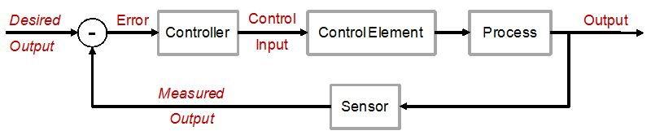

Figure 2.1, control system block diagram. (Abdallah & Kennedy, 2013)

## Active Compliant Control, A Critical Review of Current Literature

This section will look at active compliant control strategies currently being investigated and implemented in robotics today. It is hoped that what is learned from this study will directly help to develop a control algorithm for use on the future compliant actuator described later in the report and eventually on the electrically assisted turbocharger research project, allowing the apparent inertia of the turbo to be altered as mentioned previously in section one.

A definition of compliant control was given by Schutter 1987 as;

“...any robot motion during which the end effector trajectory is modified, or even generated, based on online sensor information.” (Schutter, 1987)

Due to impedance and other compliant control strategies being used mainly within robotics, particularly human robot interaction, this is where most academic papers reside. This report however is looking at these papers more generally rather than for any specific application. This generalisation is hoped to help broaden the arena of where compliant control can be implemented and to consider potential novel implementations such as the electric turbo application.

Despite dating back to as least the 1980’s, there is no standard for compliant control or its nomenclature, therefore many research papers have derived their own terminology. The two most prevalent terms for compliant control are impedance and admittance, but in describing their own work, researches have used terms such as ‘Passive adjustable compliance’ and ‘Virtual stiffness control’ (VanHam, et al., 2009) Also the terms ‘Programmable springs’ and ‘Programmable compliance’ is used by (Bigge & Harvey, 2007).

More commonly associated with electrical engineering, impedance and admittance are used to algebraically describe the dynamics of circuit elements such as capacitors and inductors, but the terms like many other aspects of electrical engineering have strong equivalences in mechanical engineering. Impedance can be thought of as inertia, resisting the resultant motion from a force input. The reason why the term inertia is not used is because inertia in thought of as being constant and unchanging like mass, whereas impedance just like electrical impedance, can be controlled. The inverse of impedance, admittance, can also be controlled. From a physics point of view impedance and admittance are two side of the same coin. If while pushing a car along a road, someone applies the brake, this will increase the mechanical impedance while at the same time reduce the admittance. The pusher of the vehicle, whom can be thought of as the environment in this example, is part of the system but is of the opposite compliance type. While you are pushing the car, you are an admittance providing a force input and the car is an impedance giving a variable position output. If the car were to start moving backwards to push you, the car would now be the admittance providing the force input and you would become the impedance trying to resist the force of the car running you over. (Hogan, 1985) (Schutter, 1987)

Compliant robots can be used for tasks that require contacting the environment, such as grinding and deburring robots. The part the robot is expected to grind needs to be of a certain size and shape. The amount of grinding required can vary so the robot needs to apply just enough force to the grinding wheel so not to damage the part. This means that the robot cannot just move straight to its commanded position but must stop when an external force is detected over a certain amount. As the part is ground down to size, the force between the robot and the grinding wheel will reduce and so the robot will move in to maintain the same amount of force ideal for grinding until the final position coordinate is reached. (Calanca, et al., 2016) (Lawrence, 1988)

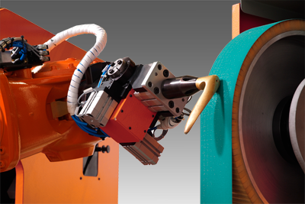

Figure 2.2, Picture of a grinding robot using compliant control. (TAM Automation , n.d)

Figure 2.2 above shows a grinding robot at work using compliant control to grind a wooden peg on a linisher. The robot will have been taught how far it needs to be away from the linisher before its task is done, but it cannot move to that position while an external force is present at the end effector. (TAM Automation , n.d) (Force Robots, 2017)

Is impedance control just a fancy form of force control? No, force control typically uses a force feedback sensor such as a load-cell to adjust applied force only, irrespective of position. According to Hogan at MIT, Impedance control is control of the dynamic relationship between force and position (Hogan, 1985). The implementation of impedance control can change the apparent inertia of an object making it seem lighter or heavier. One application of this is in the field of human robot collaboration, where a robot will be used to lift a heavy object and the human operator is able to manipulate the object as if it were weightless, this is sometimes referred to as zero gravity mode. These assistive robots need to be compliant to adjust their position and velocity based on the force inputs given by the operator. One of the major advantages of this control strategy for human robot collaboration is collision detection and mitigation. Collaborative robots need to be safe to work with and so the robots should be capable of sensing collisions with either a force sensor at the end effector, or through the change in current the motors need in order to stay either stationary in on a planned trajectory. If a collaborative robot is moving towards an object and sensors a sudden increase or decrease in current before it reaches that object, the robot should interpret that change as an environmental impact and so to stay safe it should stop moving. This will be discussed in much more detail in later sections. Another application of compliant control is in assistive exoskeletons for performance enhancement and patient rehabilitation. Elderly, disabled or even military users can now wear an exoskeleton allowing the them to lift and carry much heavier items then they are used to. (Rowell, 2003) (Tanner & Kyriakopoulos, 2001) (Hiesmair, 2016)

## Impedance & Admittance Control Strategies

A term frequently used for compliant control is ‘Backdrivability’. Being backdrivable means the environment is able to mechanically move the plant by pushing against it, and so a way to achieve compliant control is to have the plant either backdrivable or be able to mimic backdrivability by sensing the applied force and the motor driving the plant backwards itself. According to (Calanca, et al., 2016), there is a difference between backdrivability and compliance.

“In mechanical compliance, there is no need for a direct power flow from the environment to the motor,” (Calanca, et al., 2016)

An example of a mechanically compliant component is a spring that can be compressed or deflected by the environment but that compression does not affect the position of the motor, meaning that the motor has not been back driven and the force between the actuator and the environment still remains. Calanca also states that;

“…in backdrivability, there is no need for a compliant behaviour.” (Calanca, et al., 2016)

but one could argue that backdrivability *is* a form of compliance. A component that is not physically backdrivable is a worm gear, shown in figure 2.3 below. Turning the worm gear can move the worm wheel, but trying to turn the worm wheel will not move the worm gear.

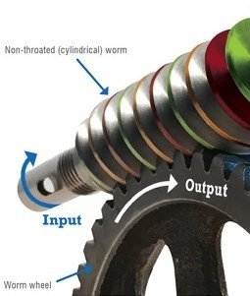

Figure 2.3, A worm gear and worm wheel. (Machinerylubrication.com, 2016)

Compliant components such as springs or elastic bands can be used to develop more compliant systems, an example of such a system is the prismatic ‘series elastic Actuator’ (SEA) from (Apptronic, n.d.) shown in figure 2.4 below. The spring element of the actuator can be adjusted in real time to achieve a desired stiffness which helps to reduce shock loading during environmental contacts in a similar way to hydraulic actuators but with the benefit of higher efficiently, as no hydraulic pump or fluid is required.

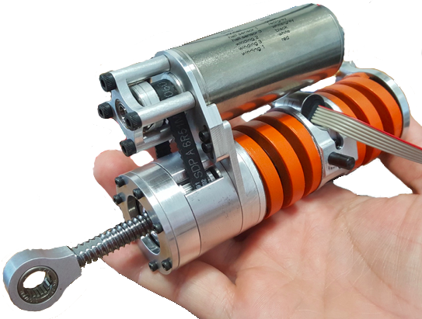

Figure 2.4 series elastic actuator, (Apptronic, n.d.)

In a backdrivable system, torque from the environment is being fed back into the plant dynamics to either add or detract from the torque being supplied by the motor which alter the output position as shown in the block diagram figure 2.5 below.

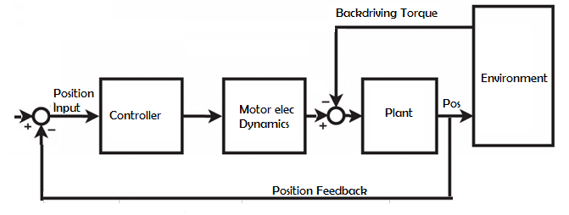

Figure 2.5, System block diagram showing backdrivability. D. McKean 2017

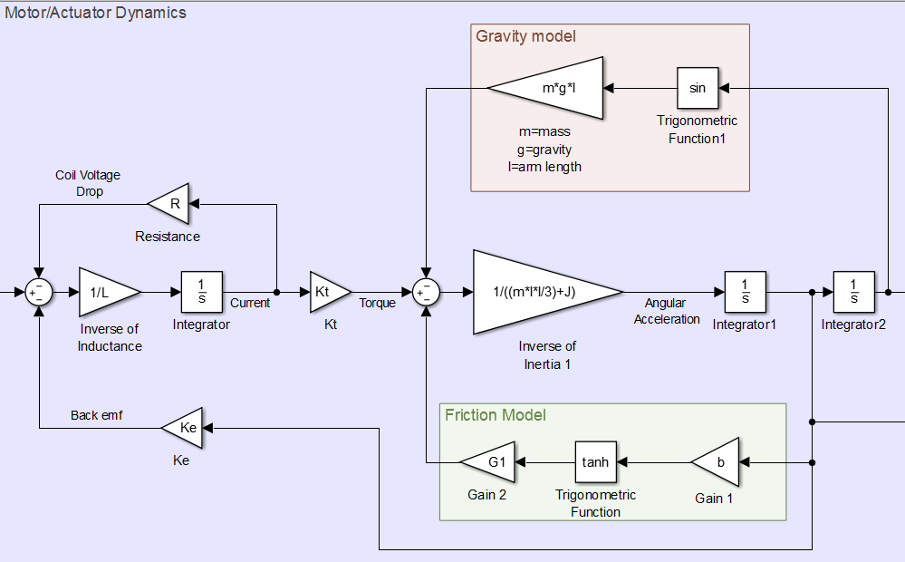

Figure 2.6, Block diagram of motor dynamics. D. McKean 2017

Figure 2.6 above is a block diagram of an actuator that will become much more familiar in chapter 4. It shows how the torque effect of gravity from an arm fixed to revolve about its end, is feed back into the actuator dynamics adding or detracting from the velocity setpoint. If the system were not backdrivable due to a gear box for example, then the effect of gravity would only have an effect on the torque needed to move the arm and could not force the arm to move the motor altering its position. It is thought that using only mechanically compliant components such as springs would not be effective enough at either achieving precise movements or preventing painful collations because the environmental collision object would still be absorbing the kinetic energy of the end effector and any material it was holding, which could be very unpleasant for a human operator, plus the controller would not know the position the end effector if it has been displaced by the spring without some way of measuring force at the end effector. (Ishida & Takanishi, 2006). The impedance control strategy used in this report is expected to use information fed back to the controller by a torque sensor and incremental encoder within the motor assembly. It is thought that sensing the collision and driving the plant in the opposite direction will have the best results in terms of safety and speed of reaction. figure 2.4 below shows the torque from the environment fed back into the controller via a torque sensor. The diagram suggests that the plant is not physically backdrivable but this need not be a problem as it is controlled. One major advantage that is proposed using virtual backdrivability is that you can have compliance in one direction but not in another, or different degrees of compliant in different directions which is not the case with mechanical backdrivability. Also, the compliance of the system can be adjusted in real time based on live feedback information where as to achieve the same in a pure mechanical system would require some very complicated devices.

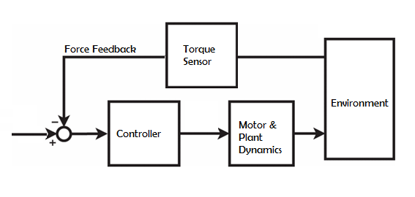

Figure 2.2, Block diagram shows back drivability by control. (Calanca, et al., 2016)

(Calanca, et al., 2016)‘s detailed paper on past and present impedance and admittance controlled strategies used since 1977 shows that the strategies can be simplified to the two block diagrams blow. The first is an admittance controller shown in figure 2.7 below. It shows the outer torque loop fed back to the admittance controller input $\frac{A\left(s\right)}{s}$ and the inner position loop fed back to a position controller input $P(s)$. The idea is that the inner position loop should be fast while the outer torque loop controls the ratio of force to position (Hogan, 1985).

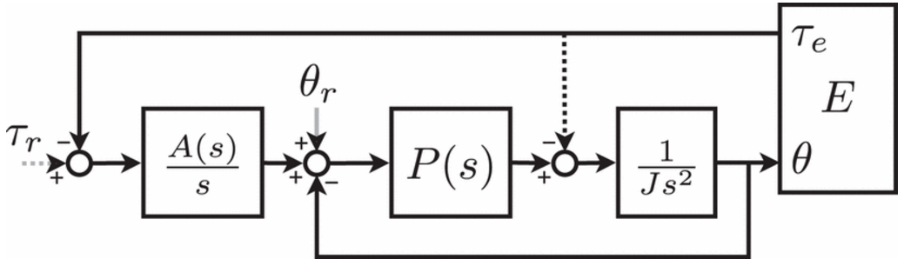

Figure 2.3, Block diagram of admittance control scheme (Calanca, et al., 2016)

According to (Ibarra & Siqueira, 2014),

“Impedance is the transfer function Z(s) that relates the position y(s) (and its derivatives) with the force F(s) of the end-effector of a robotic manipulator.”

As shown below;

$$Z\left(s\right)= \frac{F(s)}{y(s)}=I\left(s\right) \ddot{y}\left(s\right)+B\left(s\right)\dot{y}\left(s\right)+K\left(s\right)y\left(s\right),$$

Where the zeroth order K(s) is the stiffness and describes the relationship between force F(s) and position $y(s)$, the first order B(s) is the damping term and describes the relationship between F(s) and velocity $\dot{y}(s)$ and the second order inertia term I(s) describes the relationship between F(s) and acceleration $\ddot{y}(s)$. For low acceleration systems, the $I(s)$ term can be neglected. For a first order admittance, the admittance controller $\frac{A\left(s\right)}{s}$ is realised as;

|  |  |
| --- | --- |
|  | () |

Where B and K are the desired damping and stiffness of the system, an impedance controller would be the inverse. According to (Ibarra & Siqueira, 2014) this simplification of the dynamics of the admittance controller is commonly made in practical implementations. This correlates with the work of (Hogan, 1985)

The torque loop in figure 2.7 creates a virtual backdrivable component to the control system indicated by the dotted line, which means that a real backdrivable actuator is not necessary, giving you more freedom on your choice of motor transmission setup and in the opinion of this paper, greater safety. According to (Lawrence, 1988) (Adams & Hannaford, 1999) admittance control is limited when a large impedance is required because to achieve high impedance with an admittance controller, large gains need to be used with cause instability in the system.

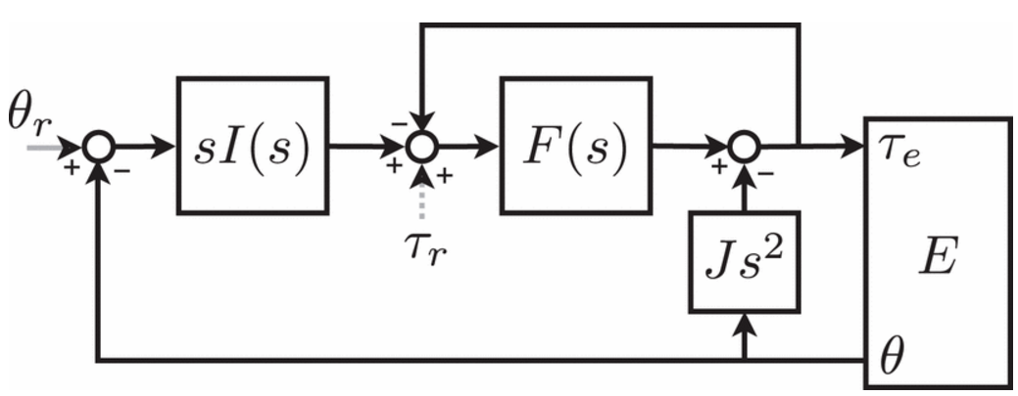

Figure 2.4, Block diagram of impedance control scheme (Calanca, et al., 2016)

Figure 2.8 above shows a simplified block diagram of an explicit impedance controlled model. According to (Calanca, et al., 2016), this strategy uses an inner torque loop fed back to a force controller $F(s)$ and an outer position loop fed to the impedance controller $s I(s)$. In both scenarios, it is the outer loop which is the main compliant control loop and these inner control loop is assumed to be fast enough that its effects on the dynamics of the plant can be neglected.

Again, there is no need for backdrivability due to the inner force loop being fed into the force controller’s input. According to (Boaventura, et al., 2013), it is difficult to have both high impedance and precise control with an impedance controller due to the inner force loop trying to reduce the force giving a softening effect as opposed to the outer position loop having a stiffening effect. (Boaventura, et al., 2013) A mixture of these approaches will be tried and tested in the controller to find the best possible result.

# Chapter 3, Proposed Hardware and Software Development

For this project, various hardware set-ups were considered based on availability, complexity and cost. In a previously authored paper on innovation, various innovation techniques were explored and investigated to try and find the most practical solution to this problem of implementing the physical actuator for this compliant control project. What follows are the results of that study together with the final actuator decision. It is important to stress that the following work is based on a previous paper submitted by the author to Loughborough College earlier this year (2017) and contains approximately 2000 words. The previous paper was deliberately written to be used in conjunction with this project in order to find suitable actuator ideas. Consideration was given for only including the results of the innovation techniques, however it was thought that it would be better and less ambiguous to provide some context and background to the techniques used and how the results were decided upon.

## Selection of Innovation Techniques

According to two authors of a paper on innovation techniques; Vullings and Heleven (2013), in order to find the ideal techniques to work with, it must first be considered whether the problem at hand is a product or service, closed or open, to be worked on by a group or an individual and whether new ideas need formulating or witling down from a few already prescribed ideas. The problem in question so far has only a few conceptual ideas; a single revolute actuator, and a simple wheel mounted to a motor. Ideas for control so far include using a microcontroller with a Matlab user interface. Matlab is preferable as it should integrate well into a mathematical model. So, step 1, more actuator/controller concepts are required. This project will only be worked on by the author and so only individual techniques will be considered. As there are likely to be many possible solutions, the open techniques will be used, and it is hoped this project will ultimately end with a viable product, therefore ‘product’ techniques will also be used. Using these constraints, the number of techniques can now be reduced to those likely to give reasonable results. The table below in figure 5 shows the full list of potential innovation techniques investigated with the techniques being used highlighted in red.

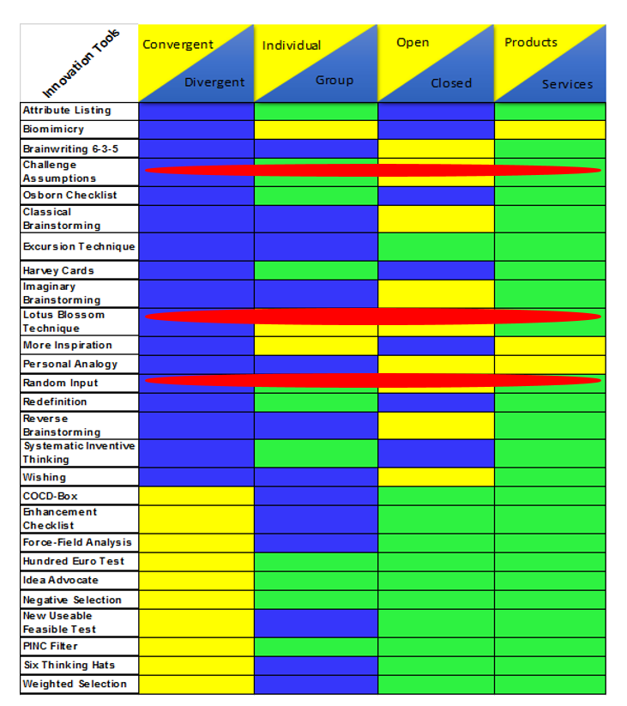

Table 3.1, Selecting Appropriate Techniques. The rows highlighted in red indicate techniques appropriate for the given problem.

Figure 3.1, Selecting Appropriate Techniques. The rows highlighted in red indicate techniques appropriate for the given problem.

As can be seen in the table above by the red highlighting, the number of innovation techniques investigated has been greatly reduced to just three;

* + Challenge Assumptions
  + Lotus Blossom Technique
  + Random Input

In the interest of science and to further strengthen the report, a technique that was thought not to be appropriate will also be chosen at random to test and to try and demonstrate that it is indeed unsuitable for this project. In any case, one shall either prove the techniques unsuitability or obtain some good new innovative ideas. Each of these techniques will now be examined to determine the most appropriate techniques to proceed with for the given problem.

## Technique 1 - Challenge Assumptions

People have innate prejudices about the world around them, a common one being; heavier object fall quicker than lighter objects. With the ‘Challenging Assumptions’ technique, the aim is to create new ideas by taking something you think you know about your system and asking yourself- “Is this true?” or “What if it wasn’t this way?” The hope is that you’ll start thinking about the system from many different point of view and discover things that you thought were fact just aren’t true, opening the door to new possibilities. Below is a table of assumptions about how the actuator in the project should be realised/modelled and some possible alternative approaches.

## Table of Assumptions

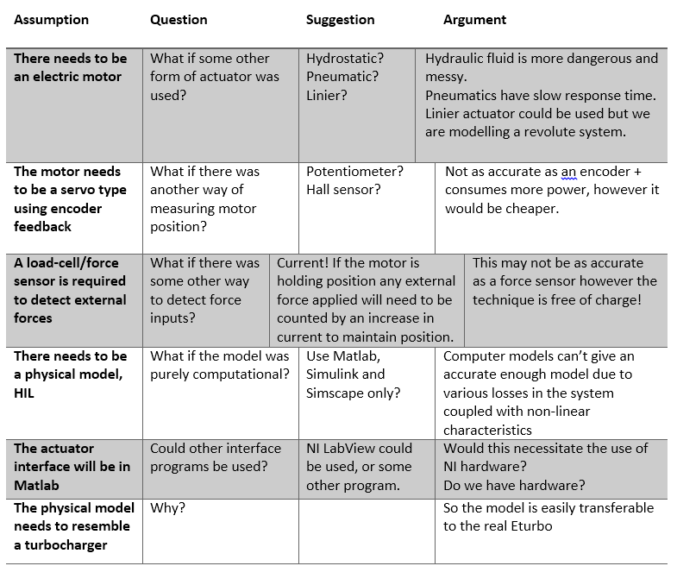

Table 3.2 Table of assumptions about system design

Figure 3.2, Table of assumptions about system design.

## Critique of ‘Challenge Assumptions’ Technique

Challenging assumptions in general is a very important process in all walks of life when trying to make decisions as your ideas and biases may be unsubstantiated. This technique has delivered some results by changing some of the original ideas of the project such as; needing a force sensor to detect force. This technique has led to the novel idea of using the motor current to detect disturbances in the system. It is not yet known if this technique will work but it is worth exploring.

Exploring the use of National Instruments’ LabView and possibly NI equipment instead of using Matlab is also something that had not been considered as it was assumed that it would be difficult to implement impedance control within LabView, but this may not be the case and should be investigated as the NI hardware and interface already exist in our laboratory.

## Technique 2 – The lotus Blossom Technique

The Lotus Blossom Technique works by having a central theme word or problem written in the centre of the Lotus Blossom from which you try to think of related words or ideas that are then written into the immediate surrounding squares, these related words are then in turn written in the centre of the outer Lotus Blossom squares to become central themes themselves. (InnovationTool.com, 2013) (Magallanes & Sánchez, 2015) (Matsumura, n.d.)

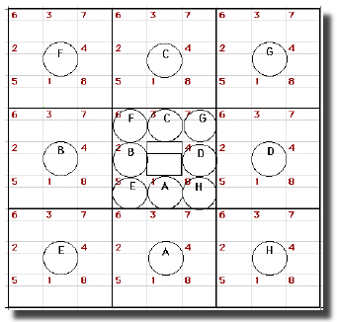

Figure 3.3, Lotus Blossom Brainstorming Technique, Matsumura.

## Completed Lotus Blossom

Below is the completed lotus Blossom, the central theme being ‘impedance Controlled Actuator’.



Table 3.3, Lotus Blossom Technique

Figure 3.4, Lotus Blossom Technique

## Critique of ‘Lotus Blossom’ Technique

The *innovation* here appears to be in the use of the tool rather than the ideas it has created. This technique has delivered unexpected results by arranging the loose ends of the project organisation, pointing out what had been forgotten or just not thought about in enough depth and has presented a rigorous framework on which to carry out further planning tasks. This will be a tremendous help in the planning of the future research project. This tool was perhaps never meant to be used in this way, but like so many other great innovations, you never know where the next one will come from. Despite no real innovative ideas at the moment, an interesting word for further investigation will be; Admittance- Is there such a thing as admittance control? After some quick investigation, yes there is and it looks very similar to impedance control. This has given the project a new exciting area of controls to investigate which may offer some innovative ideas.

## Technique 3 – Random Input

The next technique is supposed to free the mind and promote lateral thinking. To use the technique, you input a random word, not necessarily completely random as it could be related to the task or area you are working in and in fact may even provide better results this way. Starting with the random word what is the next word that pops into your head? Now see if that new word offers any useful ideas.

## Random Input Words

Random input = Glove, hand, band, sand, beach, sea, water, glass, cup, handle, Handel, music, sound, waves,

Random input = Zone, clone, body, skin, grin, chin, mausoleum, dead,

The completely random words only seem to spawn yet more random words which have proved to be no help at all. (Or have they?) It is thought that maybe if the random input was not random but instead a word related to the subject area there may be some sensible outcomes, and so below is a test to explore this idea.

Not so random input = Control, input, output, fallout, boy, girl, marriage, commitment, house, mouse, cheese, smelly, deodorant, spray,

Not so random input = Turbo, snail, whale, sea, boat, float, sink, taps, drain, sewage, waste, heat.

## Analysis and Critique of ‘Random Input’ Technique

The end word ‘heat’ is interesting because the problem of heat from the real turbo disturbing the electric motor system had not yet been explored, but it is something that will need to be investigated in order to achieve a robust system.

Going back to a previous list of words (Random input = Zone, clone, body, skin, grin, chin, mausoleum, dead,) a colleague recently entered the room and read the line and upon reaching ‘dead’ said “reincarnation”, which prompted me to say “regeneration, regen’-breaking”

This gave the idea of somehow recouping the motors excess energy in the form of electricity and storing that in a battery. Once again it seems innovation has come from an unexpected direction. This suggests that this ‘Random Input’ technique would work better as a group activity. Of course, regenerative breaking already exists and is a key part of the ETurbo, but the idea of somehow incorporating regen’ braking into the ‘hardware in loop’ model had not been thought about. This have given a new dimension to the project, particularly on how regen’ braking is implemented on a turbocharger, but it must not detract from the main objectives of the project. This technique was first thought to be the one that would return the least number of positive results. This was an unfounded predigest as it has been quite fruitful delivering two new avenues for further study, first with incorporating the effects of heat within the system due to changing currents (although not an innovative actuator idea for implementation) and then with regenerative braking and the challenge of modelling that in the system.

## Technique 4 - Wishing

Technique four is a randomly chosen technique to test its alleged unsuitability. According to the rules laid down by (Vullings & Heleven, 2013) this technique is for groups only. Wishing is a technique similar to challenging assumptions in that you simply wish that a product or system was somehow different or better and then think about why that isn’t so. The hope is that there will be some epiphany and the original thinking is somehow incorrect and that the wish can come true.

## The Wishing Table

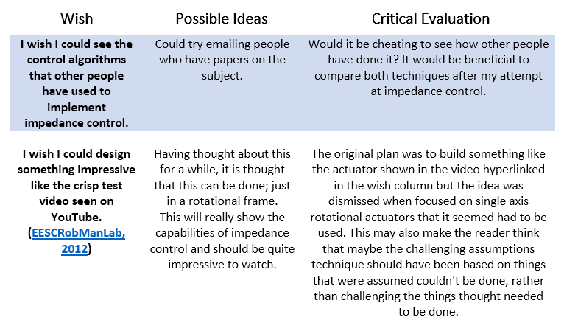

Table 3.4, Wishing Table

Figure 3.5, Wishing Table

## Critique of ‘Wishing’ Technique

Only 2 wishes were explored, but they have both already delivered result, unlike the Lotus Blossom technique there is no real need to write anything down or draw complex diagrams which means ideas can be put into action quicker.

## Critical Evaluation of Techniques Used

To recap, the techniques that have been explored and tested have been the ‘Challenging Assumptions’ technique, the ‘Lotus Blossom’ technique, the ‘Random Input’ technique and the ‘Wishing’ technique. The last technique to be tested, the ‘Wishing’ technique, has put the whole innovation project into a new perspective. Although some good ideas did come out of the main techniques; the time and effort required was disproportionate when compared to the ‘Wishing’ technique. This is not to say that the first three techniques aren’t useful, ironically, it was felt that the first three would be better suited to group activities where there is a lot of input as opposed to the ‘Wishing’ technique which is meant be a group activity seems better matched to loan working where time is more critical as this technique delivered results almost instantly.

A recap of the new ideas is presented in the table below.

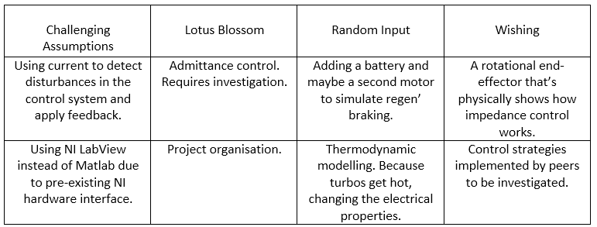

Table 3.5, Table of ideas from innovation tools.

Figure 3.6, Table of ideas from innovation tools.

## Investigation into Brushless DC Motors for Compliant Control

Brushless DC (BLDC) Motors or ac servo motors or permanent magnet synchronous motors as they are sometime called have similarities to both conventional DC and AC motors. They are similar to brushed DC motors in that they both have permanent magnets and linear speed torque characteristics and similar to AC motors due to their electronically controlled or commutated rotating magnetic fields. Other types of synchronous motors such as switched reluctance and hysteresis motors employ steel rotors as opposed to the permanent magnet rotors of BLDC motors and these steel rotors must have their magnetic field induced into them by their stator windings.

(Glueck, 2013)

Some of the advantages of BLDC motors over more conventional brushed DC motors are;

* Higher efficiency and dynamic response.
* Reduced maintenance and longer operation due to a completely sealed unit, no replacing of brushes or commutators that requires skimming/cutting.
* Greater speed/torque characteristics in a reduced package.
* Better heat dissipation as the winding are on the stator and so the case of the motor works as a heat sink and can dissipate heat to the air.
* More precise control due to internal position measurement and sometimes torque feedback.

(Yedamale, 3003)

A potential disadvantage of BLDC motors is the complex control system required to drive them along with the added cabling for power and signal of the feedback system.

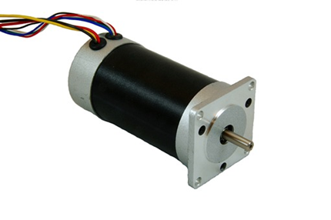

Figure 3.7, In-runner BLDC Motor, TI.com 2017

Figure 3.7 shows a typical in-runner type BLDC motor. BLDC motors are easily distinguishable from brushed DC motors by the number of wires. Brushed DC motors only have two wires for power and earth whereas BLDC motors have wires for each phase as well as for the feedback encoder or hall sensors. The term in-runner refers to the rotor which rotates inside the motor assembly.

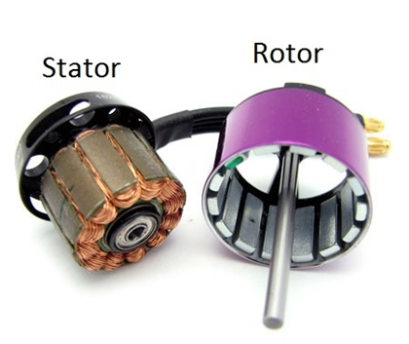

Figure 3.8, Out-runner BLDC Motor, DroneTrest.com 2014

Out-runner or Cup type BLDC motors as shown in figure 3.8 are very popular as they can achieve higher torque at a lower rpm due to the physical size of the rotor which can accommodate more magnets giving a stronger B field. These types of motor are widely used inside computers as cooling fans due to their small size and high power density.

## Control of BLDC Motors

While BLDC motors are mechanically relatively simple, they do require sophisticated control electronics and regulated power supplies. The system employs a six-step commutation sequence for each electrical revolution. For a motor with two pairs of magnets, two electrical revolutions are required to spin the motor once. Figure 3.9 below shows a typical drive set up for a typical BLDC motor. The controller shown as a PIC in the diagram below uses the inputs from the Hall sensors to determine rotor position, it then outputs Pules Width Modulation (PWM) signals mimicking the shape of a trapezoidal waveform to the transistor driver which in turn drives each of the transistors to energise each motor phase coil.

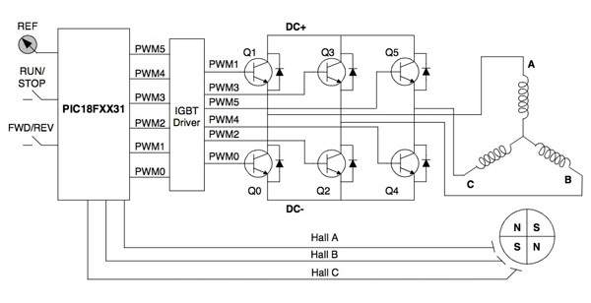

Figure 3.9 BLDC power supply/control system. Microchip

Figure 3.10 shows the relationship between the Hall sensors and the phase energization separated by 120 degrees. There are always two phases energized at any single point in time, one with positive current and one with negative current. The third phase is switch off. Now by connecting the three phases together in a wye/star configuration, the neutral point, (which is a wire loop around the stator connecting all ‘phase nots’ together) allows the current to flow out of phase V, and into phase W, which can be seen in for example in figure 5 showing three coil pairs wired in series and in reverse winding direction, and figure 6 which show the same principle.

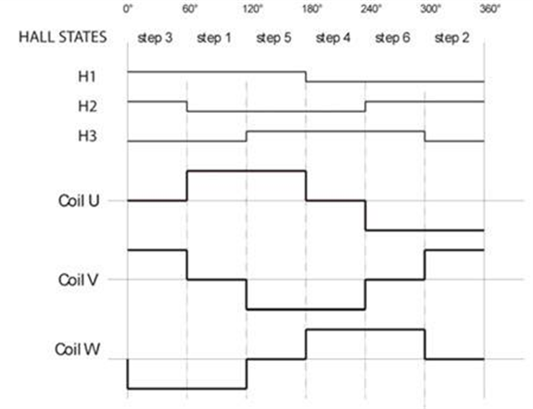

Figure 3.10, Hall sensor and coil excitation. Digikey.com 2013

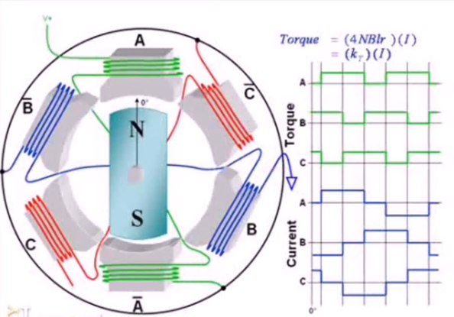

Figure 3.11, Diagram showing phase nots connected by neutral wire loop. DigitalPimple 2012

In figure 3.11 above it can be seen that if the transistor for phase A is pulled high and the transistor for phase B is pulled low then the current path is through coil A, out of coil Anot, around the neutral wire loop to coil Bnot and out through coil B to ground. This configuration means only two transistors need to be activated at any one time greatly simplifying the switching topology.

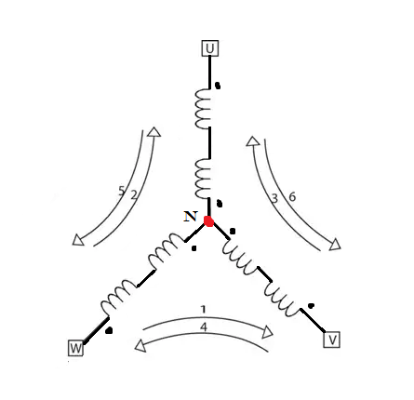

Figure 3.12, 3 coil pairs in series Wye configuration

with reverse wiring direction.

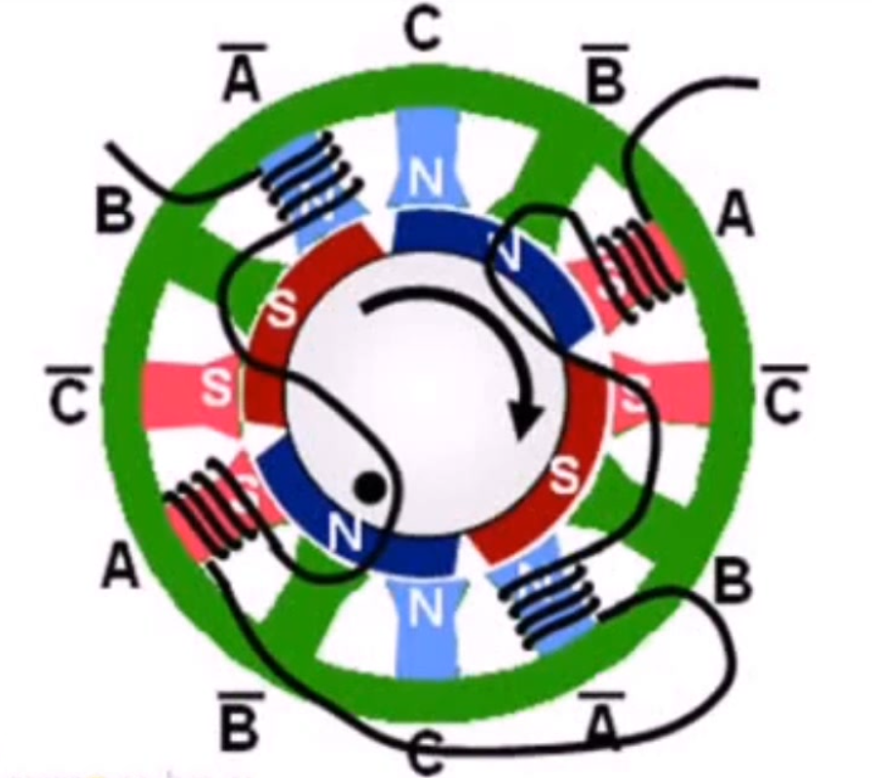

Figure 3.13, 12 pole rotor wiring configuration. DigitalPimple 2012

The three phases of a real motor stator such as that of the Kollmorgen AK24D servo motor described in this paper are actually divided between twelve stator poles. This allows more rotor magnets to be used for greater control of the motor and more torque. Figure 8 shows how the phase coils are wired together; first from coil A wound in one direction creating a south magnetic field in the air gap, then out of the first Anot coiled in the opposite direction to form a North magnetic field, and then looping around to the other coil A 180 degree from the first coil A, then out through the second Anot to the neutral loop wire where it will loop back into phase C eventually returning to ground via Cnot as in the previous example.

As the rotor moves to align its North Pole to the stators South Pole, phase A will turn off and phase B will be energized and this will continue around the stator creating the rotating magnetic field that the rotor will become synchronised with.

Figure 3.14 shows the Back emf a BLDC motor. The back emf can be used to determine the position of the rotor in what is called sensorless position control.

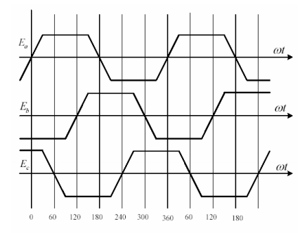

Figure 3.14, Trapezoidal back emf of a three phases BLDC motor. S. Rambabu 2007

# Chapter 4, System Modelling

## Motor Modelling

To start off simply, a standard direct current (DC) motor is modelled first mathematically then in Simulink. Once this model is working correctly and is giving sensible outputs based on given inputs the model will be given a simple PID controller described in section 4.6 This PID motor system model will then be further advanced with the impedance controller described in section 4.8. For this simple DC model, a voltage (V) is the input with an angular velocity ($\dot{θ}$) output. Figure 4.1 below shows an equivalent circuit for the armature of a DC motor and the free body diagram of the rotor assembly. Using this model and standard equations for motion it is possible to derive from first principles the differential equations describing the various physical aspects of the motor and then use these to formulate a transfer function mathematically describing the system or ‘plant’ which will then be input into Matlab/Simulink. To clarify; a transfer function is the Laplace transform of the impulse response of a linear, time invariant (LTI) system when the initial conditions are set to zero. Put more simply; a transfer function can be viewed as a black box and for a given input signal, there was a modified signal out. (Astrom & Murray, 2010)

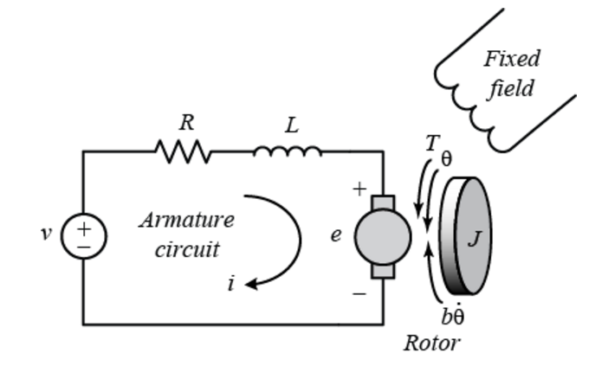

Figure 4.1, Equivalent circuit of a simple DC motor armature and free body diagram of the rotor. (Prof. Messner & prof. Tilbury, n.d.)

The physical parameters of the simple motor are as follows:

|  |  |
| --- | --- |
| Moment of inertia of the rotor | $J=0.01kg∙m^{2}$ |
| Frictional damping | $$b=0.1 Nm/rad/sec$$ |
| Back emf constant | $$Ke=0.01V/rad/sec$$ |
| Torque constant | $$K_{t}=0.01Nm/A_{rms}$$ |
| Resistance of coils | $$R=1Ω$$ |
| Inductance of coils | $$L=0.5 H$$ |

Table 4.1, Table of simple DC motor parameters

## Electric Motor modelling

The motor torque $T$ equals the armature current $i$ multipyed by the torque constant $K_{t}$:

|  |  |  |
| --- | --- | --- |
|  | $T=K_{t}i$      (Lorentz’s Law) | () |
|  |  |  |

The back-emf (electromotive force) $V_{b}$ is equal to the angular velocity $\dot{θ}$ multiplied by the back-emf constant $K_{e}$:

|  |  |  |
| --- | --- | --- |
|  | $V_{b}=K_{e}\dot{θ}$ (Faraday’s Law) | () |

and are generally considered to be equal as they are both derived from the product of the motor’s magnetic ($B$) field, the number ($N$) of coil windings, the length ($l$) and Radius ($r$) multiplied by 2: ( $2∙B∙N∙l∙r)$ therefore one can omit the subscripts and from Newton’s second law of motion ($F=ma$) and rewrite the torque in equation (1) in terms of inertia $J$ and damping $b$ giving:

|  |  |  |
| --- | --- | --- |
|  |  | () |

And from Kirchhoff’s voltage law (all voltage drops in a circuit must equal the source voltage) equation (2) can be rewritten in terms of inductance $L$ and resistance $R$ giving:

|  |  |  |
| --- | --- | --- |
|  |  | () |

The Laplace transforms of equations (3) and (4) can now be written as:

|  |  |  |
| --- | --- | --- |
|  |  | () |

And

|  |  |  |
| --- | --- | --- |
|  |  | (7) |

where $s$ is the Laplace variable.

Frome equation (6), $I(s)$ can be solved for;

|  |  |  |
| --- | --- | --- |
|  |  | () |

Substituting equation (7) for $I(s)$ in equation (5) gives:

|  |  |  |
| --- | --- | --- |
|  |  | () |

This equation shows just how intrinsically linked the sum of torques, the speed, voltage and current are to each other.

Now transpose equation (8) to create a transfer function to give us the ratio of some desired output of the system to the input, in this case the output angular displacement $\left(θ\right)$ to the input voltage gives:

|  |  |  |
| --- | --- | --- |
|  |  | () |

where the transfer function G(s) is the plant, or the DC motor in this case. Note the characteristic equation in the denominator and the denominator roots => eigenvalues. The transfer function’s eigenvalues are the poles.

Equation (9) can now be used to build a cascaded block diagram of the motor for use in the actuator model as shown below in figure 4.2.

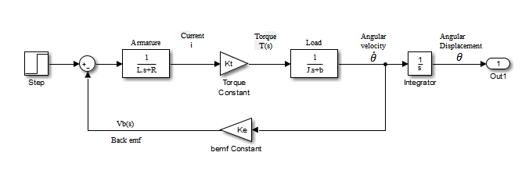

Figure 4.2, Block diagram of DC motor in Simulink®

(MIT, 2007) (Stramigioli & Babuska, 2014) (Bryant, 2008)

## Actuator Modelling

In this section, the actuator dynamics such as inertia, friction and gravitational effects will be investigated and the associated equations derived in order to mathematically model the actuator in the system.

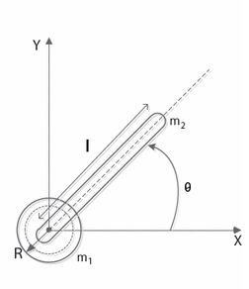

Figure 4.3, Free Body Diagram of actuator

Figure 4.3 above shows the free body diagram of the actuator and motor assembly as viewed from the front where M1 is the mass of the motor in kg and R is the radius in metres. M2 is the mass of the actuator arm in kg and l is the length in meters. A photo of the real actuator assembly is shown below.

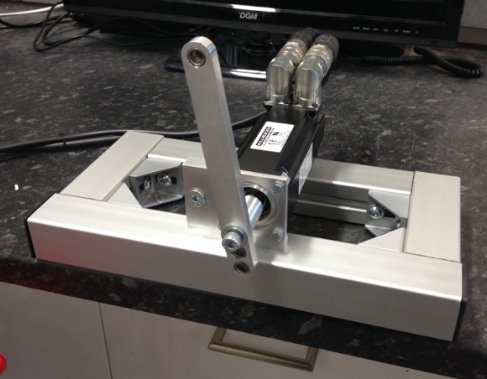

Figure 4.4, Actuator Assembly for This Project.

Figure 4.4 above is a picture of the assembled actuator using the Kollmorgen BLDC motor. The aluminium arm attached to the shaft of the motor is the part used to mimic a robot arm which people can physically interact with.

## Actuator Modelling Using Lagrangian Mechanics

Figure 4.5, Lagrange, (1736-1813)

Joseph-Louis Lagrange (25 January 1736 – 10 April 1813), was an Italian Enlightenment Era mathematician and astronomer who between 1772 and 1788 re-formulated Classical/Newtonian mechanics to simplify calculations in complex systems. These mechanics are now called Lagrangian mechanics and are denoted the script letter $L$.

Lagrange said that $L$ is equal to the difference kinetic energy and the potential energy of an object, shown in some text books as $L=$ T-V but a preferred way is to use

|  |  |
| --- | --- |
|  | () |

as this is thought to be more intuitive. To demonstrate the concept of Lagrangian mechanics, an object in freefall will serve as an example. The kinetic energy of the object is expressed as the mass of the object, multiplied by the square of the velocity, divided by two, as shown below.

|  |  |
| --- | --- |
|  | () |

And the potential energy of the object is expressed as the product of the mass of the object, the height above the reference position and force of gravity acting on the object, as shown below.

|  |  |
| --- | --- |
|  | () |

In generalized coordinates, let velocity $v= \dot{x},$ and height $h=x,$ therefore;

|  |  |
| --- | --- |
|  | () |

and

|  |  |
| --- | --- |
|  | () |

The Lagrangian now becomes;

|  |  |
| --- | --- |
|  | () |

The equations of motion can be determined by using the following partial differential equation which is acually the Euler-Lagrange formula;

|  |  |
| --- | --- |
|  | () |

This equation is taking the time derivative of the partial derivative of the legrangian with respect to $\dot{x}$, minus the partial derivative of the legrangian with respect to $x$.

The partial of $L$ with respect to is;

|  |  |
| --- | --- |
|  | () |

The partial of with respect to is;

|  |  |
| --- | --- |
|  | () |
| The time derivative of equation 2 equals; |  |
|  | () |

The equation of motion is therefore (20) – (18);

|  |  |
| --- | --- |
|  | () |

This final equation states that the acceleration of the object in freefall is equal to $-g$ or $-9.81m/s^{2}$ which is known to be true and the equation makes sense. As a side note, this equation also states that the acceleration is completely independent of mass.

The Lagrangian is equivalent to using Newton’s second law of motion; $F=ma$, meaning that the outcome is exactly the same, but the benefit to using the Lagrangian mechanics over Newtonian mechanics is that in Newtonian mechanics you are mainly confined to a single coordinate system and also have to derive every force or torque for each degree of freedom in the system individually and to the same base frame, which for a complex robotic system with multiple degrees of freedom can be very time consuming. Using Lagrangian mechanics, a generalised coordinate system can be used such as using $x$ for displacement and $\dot{x}$ for velocity rather than more specific terms like $x$ and $v$.

## Implementing Lagrangian Mechanics on A 1DoF Rotating Actuator

From physics, the Kinetic energy equation $E_{K}=\frac{1}{2} m{\dot{x}}^{2}$ can be rewritten to express rotational kinetic energy:

|  |  |
| --- | --- |
|  | () |

where are the inertia and angular velocity respectively.

(Leibniz, 1698)

Using the potential energy equation $E_{P}=mgh$, angular potential energy can be defined as:

|  |  |
| --- | --- |
|  | () |

where the height $h$ has been converted to $l(1-cosθ)$ due to the mass of the actuator being confined to a circle.

(Garber, nd)

Using Lagrangian $L$ formulation for the kinetic and potential energies gives:

|  |  |
| --- | --- |
|  | () |

Using the Euler-Lagrange (E-L) model

|  |  |  |  |  |
| --- | --- | --- | --- | --- |
|  | |  |  | | --- | --- | |  | () | |  |

The partial of with respect to gives;

|  |  |
| --- | --- |
|  | () |

And the time derivative of gives;

|  |  |  |  |  |
| --- | --- | --- | --- | --- |
|  | |  |  | | --- | --- | |  | () | |  |

And the partial of $L$ with respect to gives;

|  |  |
| --- | --- |
|  | () |

In this case the Lagrangian must account for the applied torque of the actuator and the friction damping:

|  |  |
| --- | --- |
|  | () |

Combining equations (27), (28) and (29) gives the equation of motion:

|  |  |
| --- | --- |
|  | () |

The actuator friction was modelled using the Coulomb-tanh friction model:

|  |  |
| --- | --- |
|  | () |

where is the viscus friction coefficient and $a$ is the slope of the tanh function.

(Makkar, et al., 2005) (Anderson, et al., 2006) (Kleijn, et al., 2011)

Adding (30) to (31) and expanding the inertia (explained below) gives:

|  |  |
| --- | --- |
|  | () |

The inertia of the motor is already described in the Kollmorgen product literature (Kollmorgen, 2014) as $J$ = 0.27 $kg/cm^{2}$ which in si units = $27x{10}^{-6}kg/m^{2}$ and so (32) simplifies slightly to;

|  |  |
| --- | --- |
|  | () |

Using the derivatives of $θ$ as inputs and torque as the output, the remaining coefficients can be used to build the actuator block diagram in Simulink as shown in figure 4.6 below.

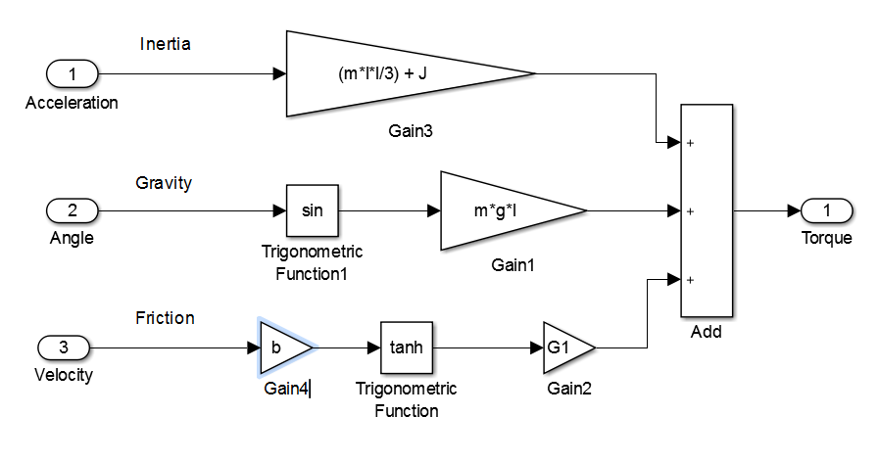

Figure 4.6, Simulink model of the opposing force acting on the motor. D. McKean 2017

(Melchiorri, nd) (Kazerooni, 1990)

## Expansion of the Inertia

The moment of inertia of the actuator arm which can be thought of as a uniform rod with negligible thickness about the end is given by the equation $J=\frac{1}{3}ml^{2}$ where $m \& l$ are mass and length respectively. In the interest of completeness, the moment of inertia of the motor being of a cylindrical construction is given by $J=\frac{1}{2}mr^{2}$, but the inertia of the motor is already provided by the (Kollmorgen, 2014) data sheet (eq 21).

## Friction

As the actuator arm is supported solely by the motor itself, only the motors viscus friction $K_{d}$ is required to model the actuator arm friction, however when applying this project to the electrified turbocharger there will be extra bearings within the turbo to consider and so it was though that a ‘Coulomb-tanh’ friction model could be used to describe the opposing friction force and would be more accurate than a simple Coulomb model $(F_{c}=μF_{N })$* without too much effort. The reason why a Coulomb-tanh model would be better is mainly because the simple Coulomb approximation does not account for friction at zero velocity or when crossing zero, also the friction factors which describe the friction between various materials are a long way from being sound and can give a friction force error of up to 20%.

* Where $F_{C}$ = the Coulomb force, μ = is the friction factor and $F_{N}$ = the normal force.

(Kleijn, et al., 2011)

Figure 4.7 below shows the newly developed gravity and friction models incorporated into the previous motor model. It can be seen from the model how the friction of the system reduces the torque of the motor and the same for the gravity model but only as a function of sin($θ$) as the actuator arm moves around in its circular path. The inertia model has also been updated to incorporate the actuator arm inertia.



Figure 4.7, Motor and actuator model with gravitational, frictional and inertial dynamics incorporated.

­­­­

## PID Control

Proportional, Integral and Derivative (PID) control is the most ubiquitous of control strategies used in industrial control and will be used as part of this controller in order to reduce the error produced by the force of gravity acting on the actuator arm. A form of ‘gravity compensation’ was originally planned to deal with this but will now need to be added to ‘ideas for future work’ folder as it has been a struggle getting this to work within the Simulink model. The major advantage to using this particular Simulink PID controller is it’s easy of tuning. It allows changes to be made to the system dynamics such as changing the length or mass of the actuator arm and then quickly retune the PID controller to compensate without having any effect on the compliant control.

The PID controller takes the incoming error signal and applies a proportional, integral and derivative term to it and then multiplies the output by some gain, either individually or combined depending on the type of controller used. The mathematical representation of PID control is described by;

|  |  |
| --- | --- |
|  | () |

where = output, $e$ = error, $K_{p}=$ proportional gain, $K_{i}$ = integral gain and $K_{d }$ = derivative gain. In their most basic form; proportional gain is simply an amplification of the current error signal which has the effect of trying to drive the error signal to zero faster relative to the gain. This provides a very quick response but the side effect of P only control is that the output signal can overshoot the desired setpoint, oscillate about the setpoint (marginally stable) or even blow up to infinity (unstable). Integral gain as the name suggests integrates the error signal and multiplies it by some gain, taking into account the past steady state error and summing it in order to drive the error to zero. Combined with P control this works well to reduce steady state error. Derivative control as the name suggests takes the derivative of the error signal which is the time rate of change of the signal and is multiplied by some gain. This has the effect of damping a fast changing signal reducing overshoot and oscillations. PID tuning is regarded by some to be a ‘dark art’ and this may be because it is usually done by hand using one’s intuition. Before the auto-tuning PID function was found in Simulink the main method of tuning PIDs was to increase P until it rises fast enough and has continuous amplitude oscillations. Next the D gain is increased to dampen the oscillations and finally if needed the integral gain is increased to remove any steady state error. (Ang, et al., 2005) (Astrom & Hagglund, 2001)

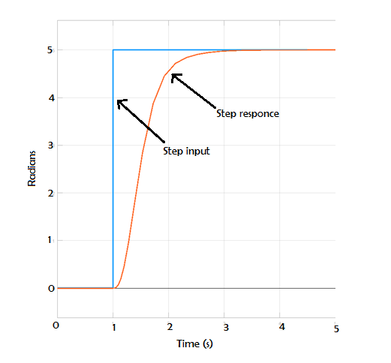

Figure 4.8, Step response of basic DC motor with manually tuned integral controller

The figure 4.8 above shows the step response of the motor model after manually tuning the PID controller. The figure shows a response time of about one second and a settling time of about two seconds. This has been tuned to give a smooth transient response and should give the controller enough time to adjust for any environmental impacts.

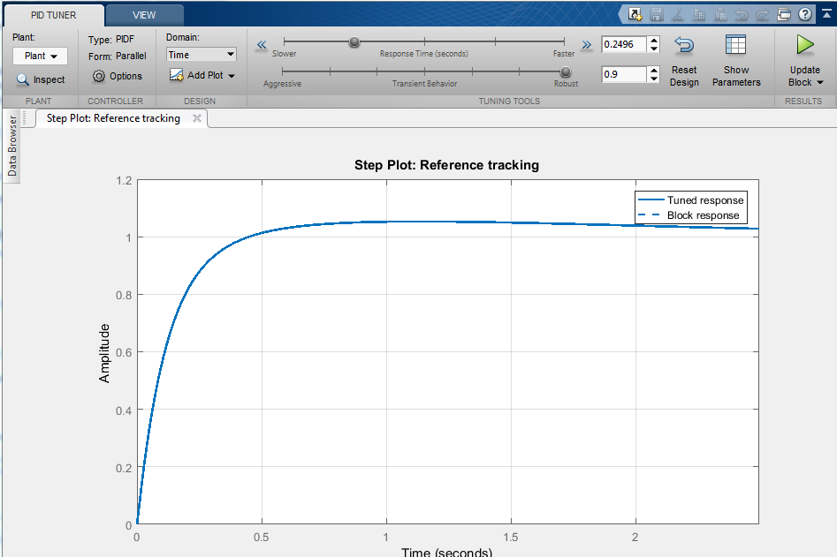

Figure 4.9, Matlab PID Tuner, Matlab® 2016a

Figure 4.9 above shows the Matlab PID tuner GUI. This tool was useful for quickly adjusting the PID gains after changing the dynamic parameters of the actuator motor/arm. It shows the step response which is then adjustable via the side bars at the top of the page.

## Impedance Modelling

Based upon the previous examples and literature on compliant control the project will use force and position feedback but also velocity feedback because velocity multiplied by the damping constant $d_{d}$ helps to dampen any oscillations in the system and preliminary results from the first iteration of controller showed that system damping was necessary, especially with high gain or with a hard contact environment. A damping gain of 4 seemed sufficient to reduce oscillations without unduly effecting the bandwidth. A stiffness gain of 3 gave reasonable results and a good balance of actuator speed and impedance. The stiffness gain of the environment can be turned up to 10 without having to alter the controller gains which shows good control and high gain and phase margin. An analysis of the results obtained will be presented later in the report.

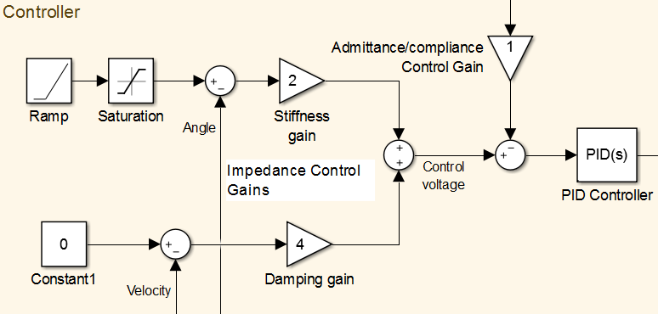

Figure 4.10 The controller block showing the Impedance, Admittance and PID functions

Figure 4.10 above is the completed controller block diagram built in Simulink®. The model shows the impedance control stiffness gain, damping gain and environmental force feedback gain. The PID controller is used for gravity compensation which is explained earlier in the report. The angle set point is controlled by a ramp function with saturation which gives a consistent and smooth angle change. The damping does have a constant used for offsetting the velocity feedback but it is not necessary and was only used for experimentation. It should be noticeable that the configuration of this controller does not fully match either of the described compliance methods detailed about. The purpose of this research was to find a new compliant control method with high bandwidth and stability and it was found through a lot of trial and error that the shortcomings of the classic impedance and admittance control methods could be attenuated by summing all feedback signals to one common point creating a hybrid compliant system. The new control method was tested by varying the environmental stiffness as well as the controller gains and the results are set out below. An analysis of the results will also follow.

## Modelling Environmental Interaction

It is necessary to be able to model the interaction between the plant actuator and the environment in order to maximise system stability. One way the actuator is able to interact with its environment is by contact with humans. The physical interaction should not harm the human in any way and so the robots needs to be able to sense the interaction and adjust its behaviour. A very detailed paper by (Speich, et al., 2005) investigates the dynamics and modelling of the human arm and suggest it should be modelled as a second order mass–spring–damper system, as this closely characterises how the human body moves when interacting with objects, and so this environmental system will be employed for the model but with the mass omitted because the actuator will not be lifting any environmental mass and therefore the system is only concerned with the spring and damping effects of the interaction. Whitney (Whitney, 1977) found that modelling the environment as an elastic system and the actuator as a mass greatly improved the stability of the plant and so this approach should help with the stability of the system too. From Hooke’s spring law $F=kθ$ and the friction damping equation $F=b\dot{θ}$ one can devise a simple model of the environment as seen in figure 4.11 below, first with the actuator angular displacement output multiplied by the stiffness gain (k) to give one environmental torque output and the second with the actuator angular velocity output multiplied by the damping gain (b) to give the second environmental torque output.

## Timing Function

The step inputs and multiplier blocks are only there to provide a timing function which simulates an environmental interaction at t1 and then removes the simulated object at t2. The step inputs simply provide a 1 or 0 at a given time which acts as a gate when multiplied by the product block. Using the timing function worked very well to simulate the interaction of an environmental object, however due to the nature of the function removing all the torque feedback data, it seemed necessary to add extra torque feedback connections just before the environmental gains. This kept a certain about of torque feedback going into the controller and prevented the actuator from overshooting during system tuning as is what happened during the original conception when the feedback was set to zero.

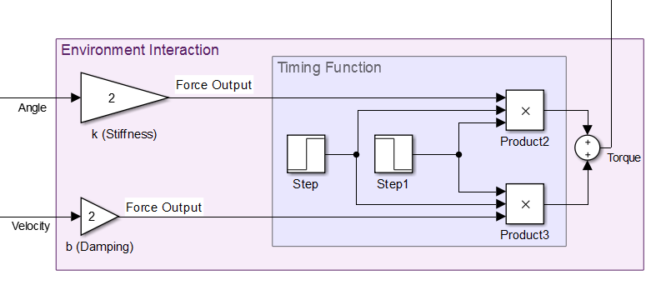

Figure 4.11 Environmental Subsystem plus Timing Function

Figure 4.12 below shows the fully assembled control system model with the controller on the left, the motor and actuator dynamics in the middle and the environment with timing function on the right. The force feedback can be seen after the environment being fed back to the controller. The angle and velocity feedback signals can also be seen between the motor and environment being fed back into the controller.

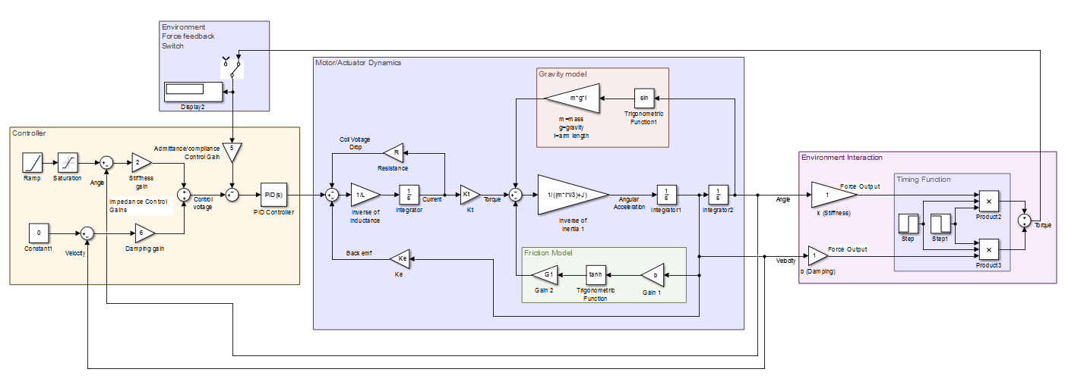

Figure 4.12, Full system model in Simulink ®

## Gravity Compensation

This is an extra section to try and show an attempt to develop some gravity compensation on the Simulink model but it thought that there may not be enough time to complete this.

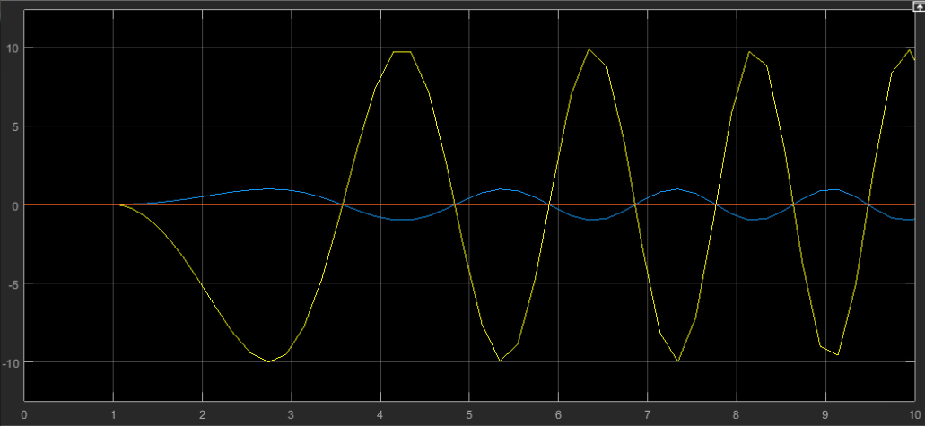

Figure 4.13, Chart showing sin of angle in blue and sin of gravity torque in yellow. D. McKean 2017

The compliant actuator, having an arm which pivots about its end attached to the motor is as prone to the effects of gravity as much as anything else. The original Simulink model didn’t have gravity compensation but after managing to get a working code in LabView it was thought that it lessons learned from LabView could be applied to the Simulink model. The gravitational effect produces a torque on the robot arm which fluctuates between zero at the vertical/top and bottom positions and maximum torque at 90 degrees to the vertical. The amount of torque applied to the arm by gravity between these positions is the sin of motor position multiplied by the mass of the arm and the distance from the centre of mass (CoM) of the arm to the centre of rotation (CoR). Figure 4.13 above shows a chart that displays the sin of the model position in blue and the sin of the position multiplied by the effect of gravity on the mass of the robot arm which has been set to $-10m/s^{2}$ for simplicity. This is the first step to creating gravity compensation as it proves that there is stable system to start with before feeding this signal into the motor dynamics. To produce the gravity compensation, it was though that the same values that were used to add the gravitational effects to start with could be used to apply the compensation.

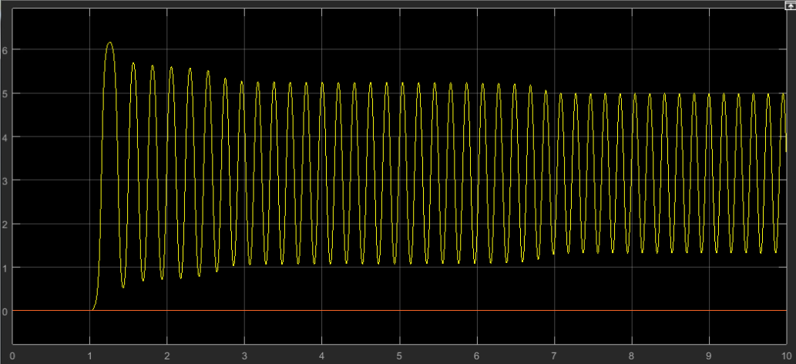

Figure 4.14, Gravity Comp chart. D. McKean 2017

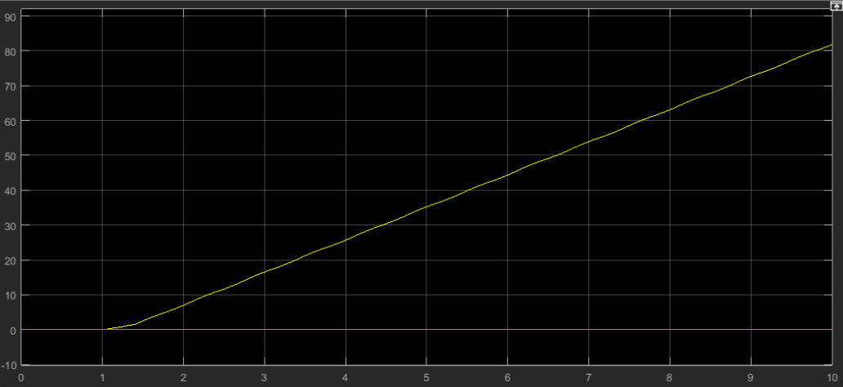

Figure 4.15, Gravity comp chart. D. McKean 2017

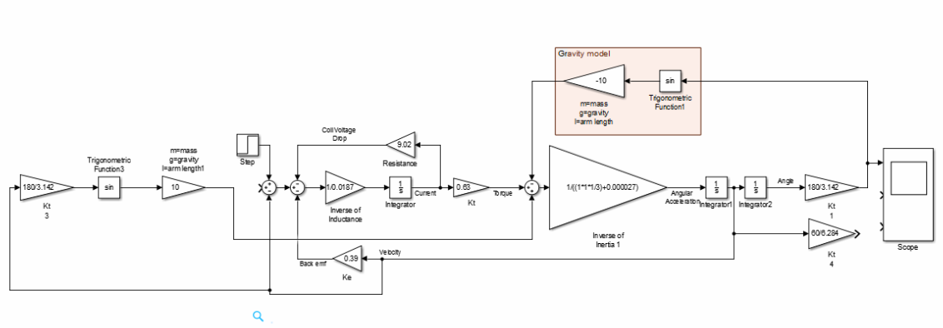

Figure 4.16, Block diagram showing an attempt at adding in gravity compensation to block diagram. D. McKean 2017

## Simulation Results

What follows is the results obtained from the simulated impedance controlled actuator system. A number of charts will be displayed showing system output angle and velocity curves at various controller and environmental gains.

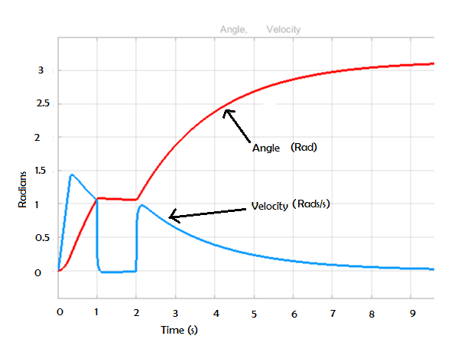

Figure 4.17 Graph showing the pause in angle displacement (Red) & reduction in actuator velocity (Blue) during an environmental impact at time t=1s to t=2s. Gains: K=2, d=6 ke=2 de=2

Figure 4.17 above shows how the actuator arm which is commanded to move from its rest position to a setpoint of 𝜋 radians/180 degrees. It can be difficult to determine stiffness and damping gains for the environment when the environment is a human arm because these parameters can vary quite widely and change quickly. Therefore, arbitrary values were first selected for the stiffness and damping gains. The stiffness of the arm is set to k=2 and the damping is set to d=6. The environmental stiffness and damping are both set to ke=2 and de=2. The arm stops advancing when an environmental impact is detected at t=1s. When the environmental object is removed at t=2s the actuator is free to continue advancing to the desired set point angle. Notice how the angular velocity (blue) drops to zero rad/s while the environmental object is in its way. Notice also how the angle of the arm (red) has remained stationary while the object is present. There is also no resonance or instability in the system.

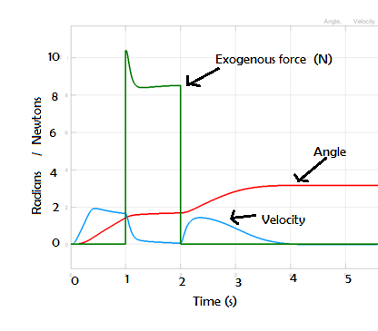

Figure 4.18, Graph showing the exogenous force feedback in green.

The above graph figure 4.18 includes the environmental exogenous force feedback shown in green. It highlights how the actuator arm is prevented from continuing while an environmental object is present. Once the object is removed the speed immediately returns moving the arm to its setpoint. Notice also how the exogenous force peaks at the beginning while the actuator velocity is still high and the actuator has not yet stopped moving. Once the actuator has stopped, the exogenous force remains constant.

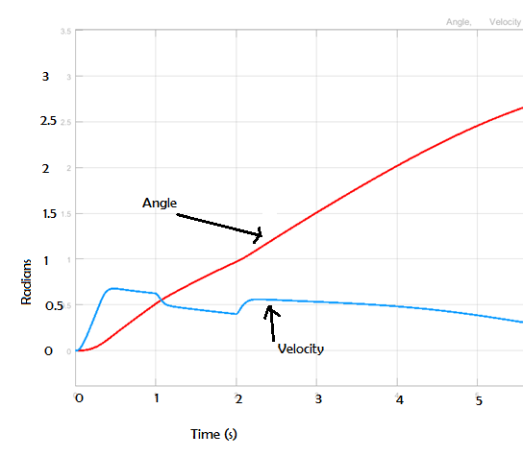

Figure 4.19, Controller reacting to the dynamics of the unloaded system.

Figure 4.19 above is interesting because it shows how the controller reacts to the dynamics of the system when there is no environmental interaction. The blip between t=1 and t=2 seconds is just the system dynamics being fed back into the controller. It shows that the system dynamics are a real phenomenon although the effects are small due to the use of small parameters since there is not a lot of deviation.

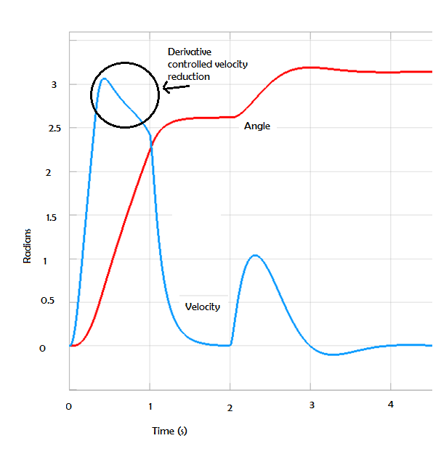

Figure 4.20, Graph showing environmental impact with high actuator stiffness gain. k=10 d=6 ke=2 de=2

The above figure 4.20 shows that even when the stiffness gain is set relatively high k=10, the controller acts very quickly to reduce the speed to 0 halting the arm. Immediately after the event, the speed increases quickly again and the arm moves to its setpoint of 𝜋 rads. The black circle shows the velocity reducing before the exogenous impact. This is only the result of the damping gain of the controller which acts the same as a derivative element in a PID controller, noticing that the actuator arm is almost at its setpoint and so is reducing the velocity to help prevent setpoint overshoot.

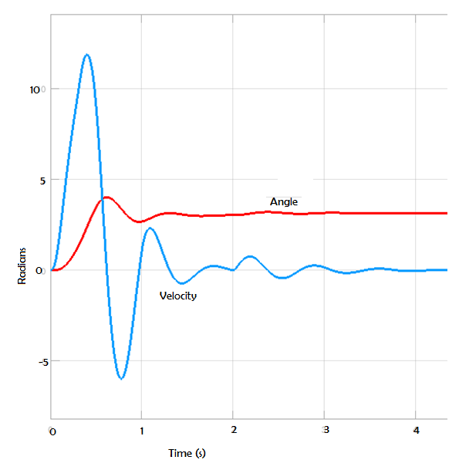

Figure 4.21, Graph showing unstable operation @ k=50 d=6 ke=2 de=2.

Figure 4.21 above shows that there are limits to the stiffness gain. Having the gain set too high causes the motor speed to increase too quickly for the controller to adjust for any deviation of the setpoint. This causes oscillation in the system as it tries to recover.

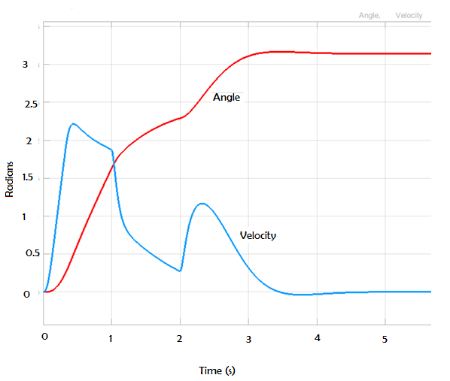

Figure 4.22, k=7 d=6 ke=2 de=2.

Figure 4.22 above shows the stiffness gain set to k=7. The result is the environmental impact does not fully stop the arm from moving. The velocity is reduced from about 1.8 rad/s to about 0.3 rad/s therefore the angle continues to increase just at a reduced rate.

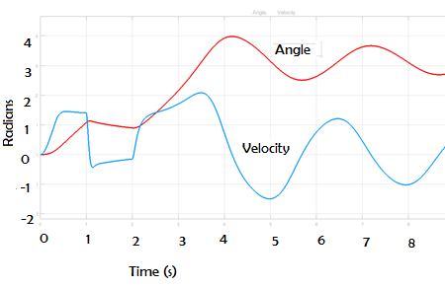

Figure 4.23, Graph shows the effect of an underdamped system gain. k=3 d=3 ke=10 de=10

Figure 4.23 above shows the effect of an underdamped system. Reducing the damping gain by half gives rise to large oscillations in the arm speed and position.

## Discussions

Analysing the frequency response of the actuator arm in real life can be done by setting the arm parallel to the ground and then subjecting it to a sinusoidal input signal of about 1Hz at some amplitude relative to the system under test, then increase the frequency of the input until the output becomes unstable and wonders out of phase relative to the input signal. This will give the bandwidth of the plant. This frequency sweep can also be done mathematically using programs like Matlab®/Simulink® and the ‘Linear Analysis Tool’. This section will analyse the simulated system and check the stability and bandwidth.

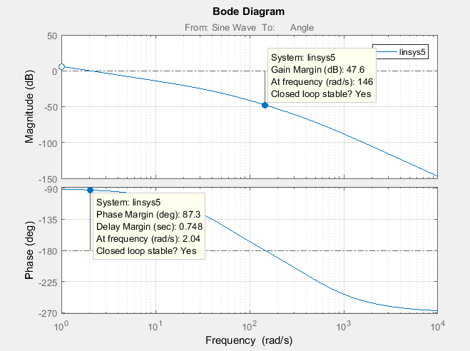

Figure 4.24, Bode plot of the open loop actuator.

Figure 4.24 above shows the phase and gain margins of the system. One the Bode plot, the phase margin is the difference between the phase curve and -180 degrees at a point corresponding to the frequency that gives o decibels (dB). The gain margin is the difference between the magnitude curve and 0dB when the phase angle drops below -180 degrees. Figure 4.24 shows just how stable this system is. The gain margin is 47.6 dB and the phase margin is 87.3 degrees with means that there is a lot of room for error and the system is very stable.

## Chapter Conclusion & Recommendations for Further Work

The results show that this system performs exceeding well within the parameters in which it has been tested. It works precisely how it was intended but of course it cannot be proven to work fully until it is implemented on control a real motor. So far it can be said that hybrid impedance/admittance control works. It is possible to have high impedance at the same time as having the actuator move quickly and precisely. It works well to reduce the force of collisions with environmental objects which could include humans who are working with the actuator in the form of a robot, perhaps on a manufacturing assembly line. And if it can do that, then it should also work to shape the apparent inertia of an electric turbocharger on an engine. However, turbocharge spin much faster than this model and that has not been tested for as yet.

In order to make the testing of this new controller more rigorous, a selection of controllers could have been built to mimic one already designed by researches in literature. Setting all the environmental interactions the same and with the same input, the variance of the different architectures could be seen which may also give a better understanding of how these systems work and allow for even better model to be built.

There are still plans however to continue this work in a research context at Loughborough university and it is hoped that this will be in the form of a PhD in control systems and compliant control. To continue this work, the actuator system model needs to be migrated into a LabView program to work with the Kollmorgen BLDC motor system that is already in position and waiting. A few different ways of applying this model have been proposed. One is to rewrite the model directly into LabView. Another is to use a ‘Math Script’ block where the Matlab .M file could be written, this would also work using a .cpp file. Another way is to convert the Simulink code into HDL (hardware description language) code which could then be run directly on the Xilinx FPGA target on the National Instruments Compact Rio controller. If the research work on the electric turbo is to continue, then assuming the physical test of this controller is acceptable than the strategy should be applied to the turbo controller and validated for use on the research engine. This work could be expanded on by applying the control strategy to a multiple DoF system and seeing if it is still just as stable.

# Chapter 5, Physical Implementation of The New Control Algorithm

## Physical Setup

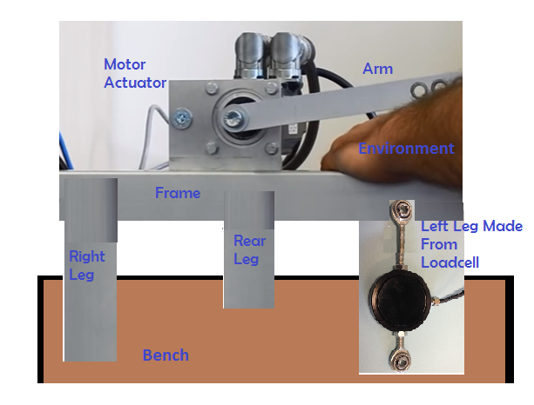

Figure 5.1, Proposed actuator and loadcell setup. D. McKean 2017

Figure 5.1 above show a conceptual hardware setup using a Kollmorgen servomotor fixed to a small table where the left leg has been replaced by a loadcell. The idea was that when the arm comes into contact with the environment by perhaps pushing down on a person’s arm, the load on the load cell will reduce as the force is transferred to the persons arm.

As mentioned in chapters 1 and 2, the actuator is comprised of a Kollmorgen brushless direct current (BLDC) servo motor with a single degree of freedom arm attached to the rotor. The motor assembly is secured with an aluminium bracket to an extruded aluminium frame that was purpose built for this project. The aluminium arm which is 200mm in length and weighs 100grams, was not specially made but was found to make an ideal arm with its appropriate size and weight. The holes were also convenient for mounting the arm to the motor rotor and the arm could be moved to different holes to test how the dynamics changed due to small length changes. The reason for using an arm rather than a simple rotating disc which would have more closely resembled a turbocharger assembly, was because it was thought that an arm protruding from the motor would be better and easier to interact with the environment and because all the prevailing literature about compliant control was based on robot arms and not simple rotating discs or uniformly rotating mechanisms of any kind. It has since been realised in reflection that gravity compensation which is discussed in chapter 5.9, could have been achieved with the addition of a counter weight attached to the short end of the arm cancelling out the weight of the opposing end and thus eliminating the problem of gravity compensation within the control algorithm, in fact the whole gravity aspect of the actuator arm could have been removed from the dynamics model leaving only the mass moment of inertia of the rotor which is given in the Kollmorgen technical literature. Conversely, using an arm has meant that the effects and cancellation of gravity have had to be learned and this will indeed become useful in the future when working with robotic systems with arms.

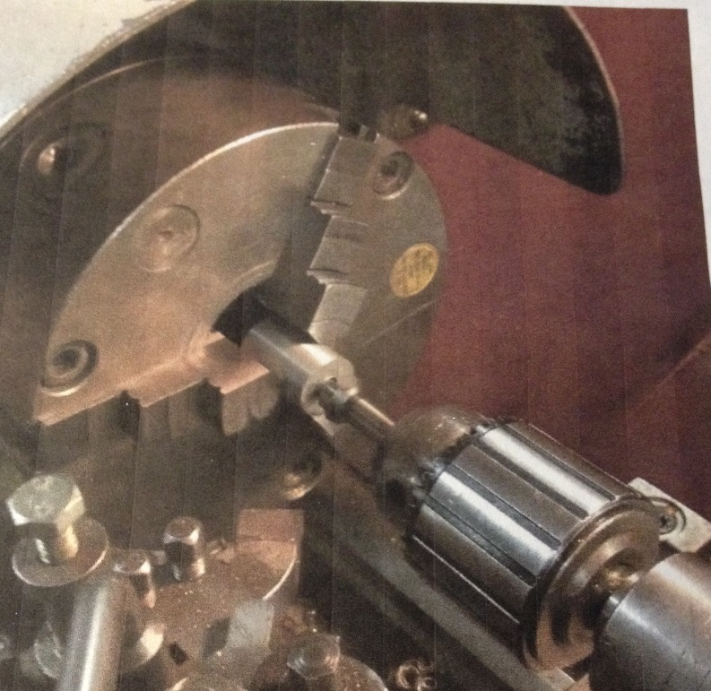

Figure 5.2, Turning up a boss on the lath. D. McKean 2017

Figure 5.2 above shows a boss being turned up by the author on a manual lathe in one of the mechanical workshops. What can be seen happening in the figure is a deburring tool being used to remove the any burs made from drilling and to add a slight chamfer to help with tapping the 8mm thread. This boss will be used to mount the arm of the actuator onto the motor rotor spigot.

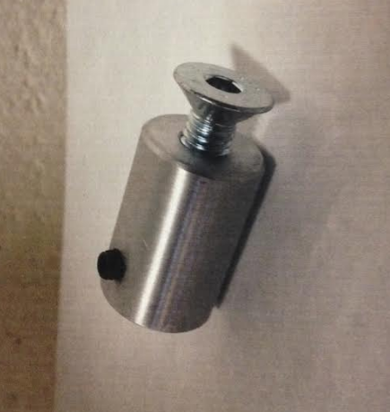

Figure 5.3, Mounting boss. D. McKean 2017

Figure 5.3 above shows the completed boss with an axial 8mm tapped thread for mounting the robot arm and orthogonal 4mm tapped thread for securing the boss onto the motor shaft.

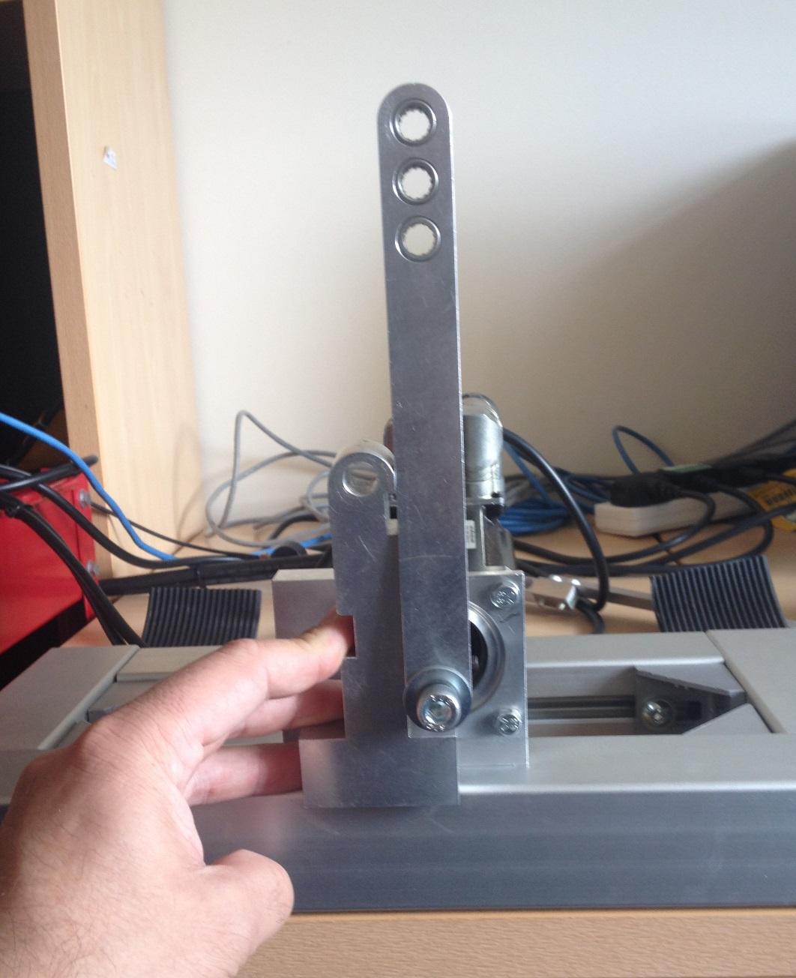

Figure 5.4 Calibrating the zero degree point on the motor, D. McKean 2017

Figure 5.4 above shows how the actuator arm was calibrated to zero degrees at top dead centre. The calibration tool was adapted from an existing work piece that was made flat and square in order to have the arm square relative to the mounting frame.

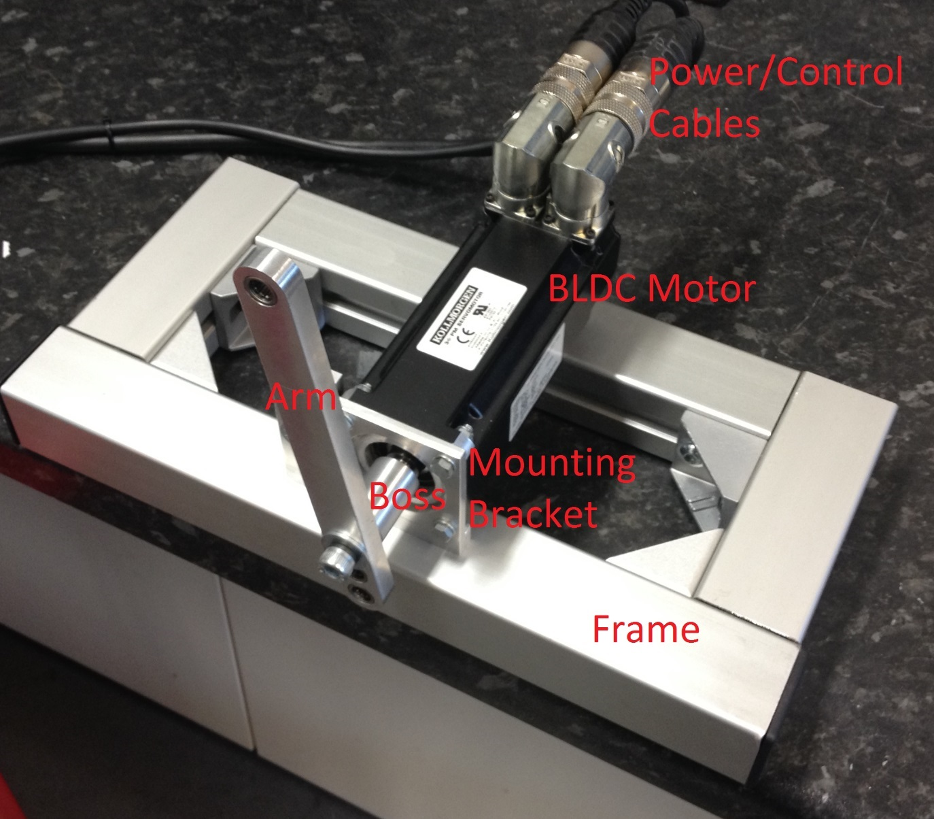

Figure 5.5 Picture of Actuator Assembly, D. McKean 2016

Figure 5.5 above shows labelled picture of the servomotor setup on a frame build by the author from extruded aluminium.

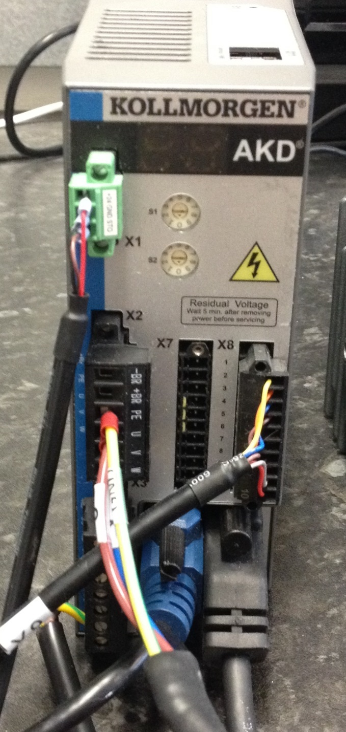

Figure 5.6 Kollmorgen AKD Servo Drive, D. McKean 2016

Figure 5.6 above shows the Kollmorgen AKD servo drive. This drive houses all the insulated gate bipolar transistors (IGBTs) for switching between the different coil phases within the BLDC servo motor as discussed in chapter 3.17 on BLDC motor control.

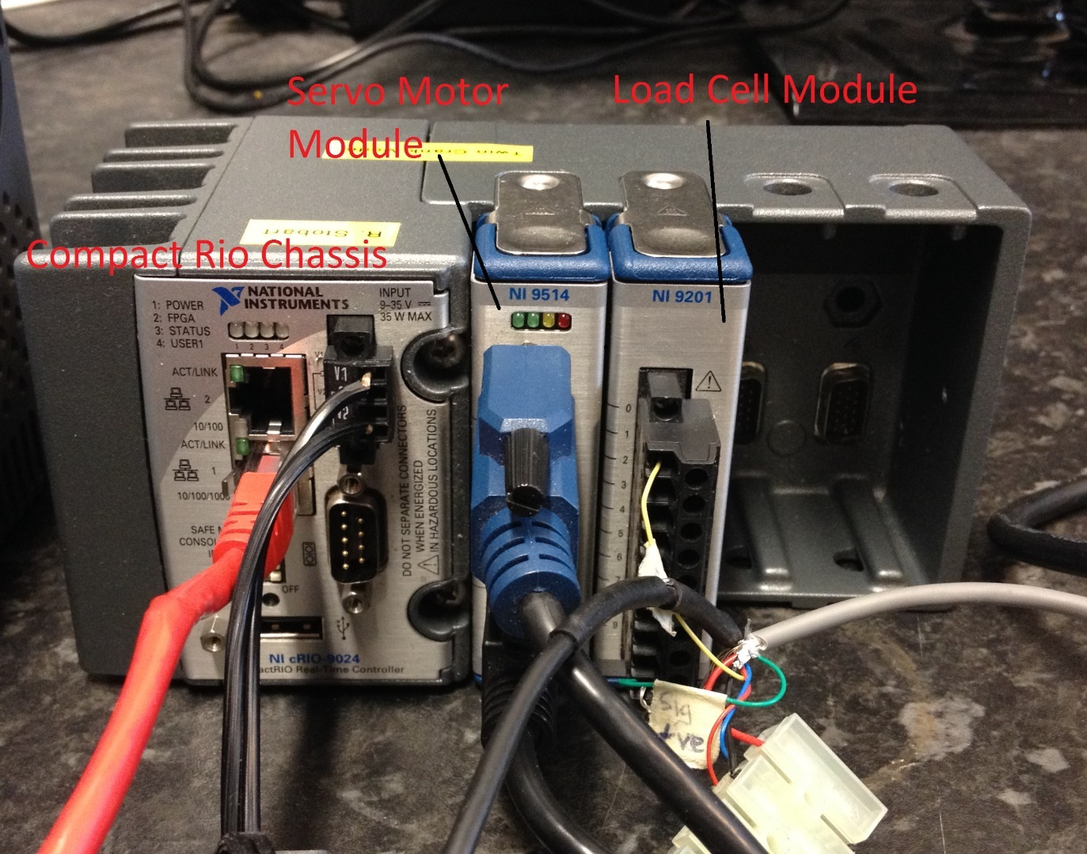

Figure 5.7 Compact Rio Assembly, D. McKean 2016

Figure 5.7 above shows the National Instruments (NI) Compact Rio which is an embedded controller featuring a real-time processor for communications and signal processing and a user programmable Xilinx FPGA for high-speed control. The NI9514 servo motor module is the interface between the LabView code on the PC and the Kollmorgen servo drive. The NI9201 is an analogue input module for the loadcell output signal when used.

## User Interface

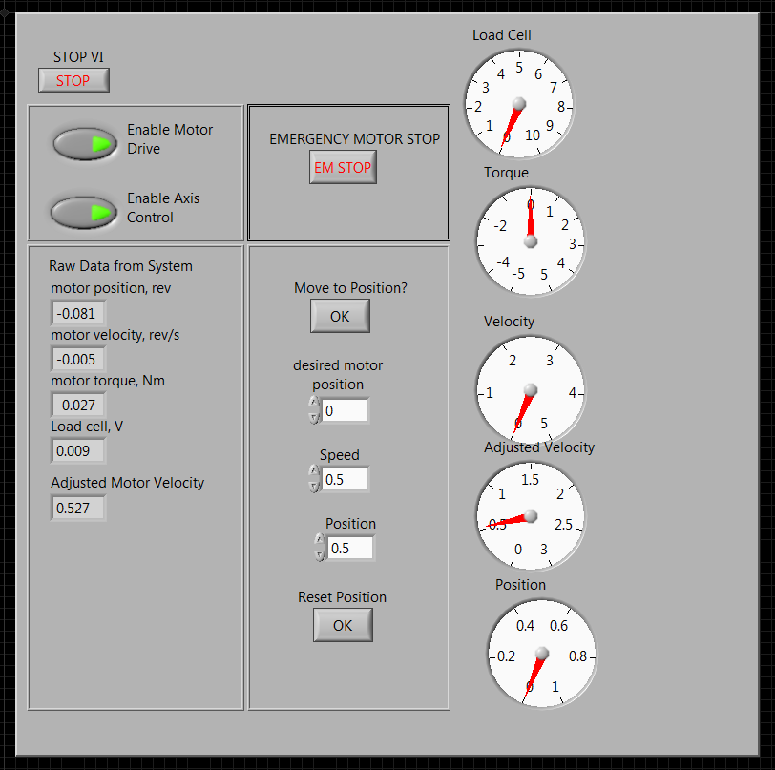

Figure 5.8 LabView GUI designed by the author. D. McKean 2017

Figure 5.8 above shows the LabView user interface, sometimes referred to as a GUI (Graphical User Interface). This GUI has been designed and implemented by the author for this project. The left side of the GUI is the control side and has been designed to allow the motor to be controlled in one of two ways; either the motor can be commanded to move to a given position by using the ‘Desired Position’ input box and pressing the ‘Move to Position’ button, or the motor can be commanded to perform a certain number of revolutions at a given RPM by entering the desired RPM into the ‘RPM’ input box and the number of revolutions into the ‘No. Revolutions’ input box, then pressing the ‘Start Test’ button the motor would carry out the command. Within the LabView code itself found in appendix 2 other dynamic properties are added, such as acceleration and deceleration of the motor. Other features of the GUI are ‘Enable buttons for the drive and axis, and an ‘Emergency Stop’ button which was very handy during some validation and testing of the actuator. The right side of the GUI is the ‘Data Acquisition’, where the data from the motor’s speed, position and torque sensors are displayed along with the data from the external load cell which is shown in figure 38 below. This side of the GUI is also used to save the raw data from the sensors and create Excel files for easy data visualization.

## Force Measurement

This chapter is about how the force on the motor is measured. Force can be measured either directly via a force sensor such as a loadcell, or indirectly but measuring the current in the motor and multiplying the value by the motor’s torque constant $K_{T}$ to give a torque value. This was one of the ideas proposed while exploring the innovation techniques in chapter 3.2.1, table 3.2.

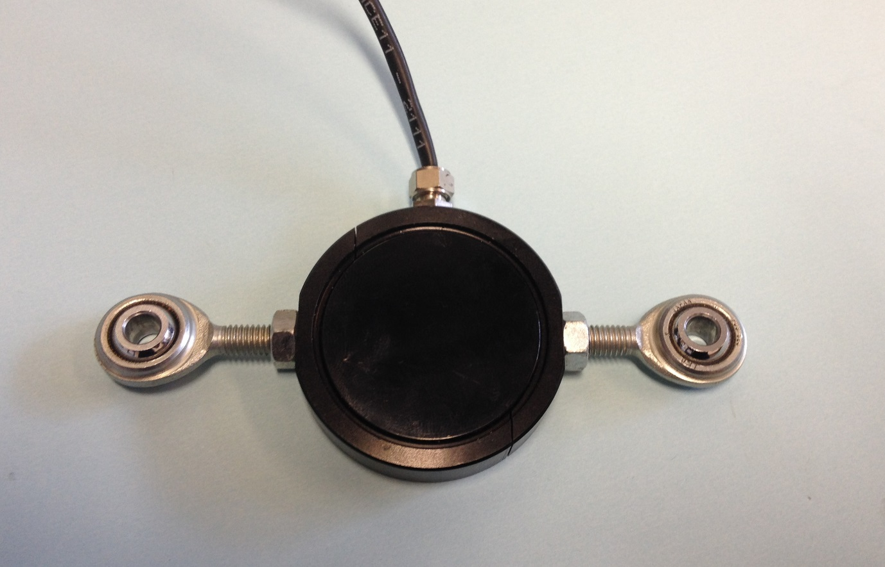

Figure 5.9, Load Cell, D. McKean 2016

The early proposed actuator setup shown in figure 5.1 depicted a loadcell similar to the one shown above in figure 5.9. This loadcell can only work effectively by being squeezed or pulled and will not work by applying a torque to twist the loadcell.

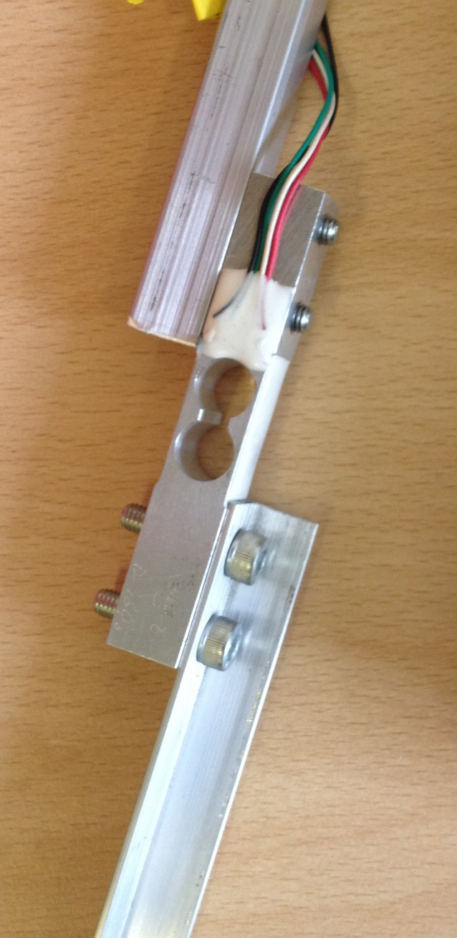

Figure 5.10, New torsional load cell attached between two members forming a new robot arm. D. McKean 2017

Figure 5.10 above shows an alternative loadcell. This type of load cell is used for measuring bending moments and so would apply itself well to being mounted directly onto the robot arm. The loadcell and mounting arm were assembled by the author. The loadcell was salvaged from an old set of electronic weighing scales. A loadcell amplifier circuit was also built using an instrumentation opamp chip but sadly the circuit when missing before it could be tested. Due to this unfortunate incident, the torque value produced by the motor itself was used instead and proved to be very accurate.

## System Testing Methodology

Once the LabView code was fully assembled and a project had been created to run the code and communicate with the hardware, the first task was to test the basic motor control system without and exotic control algorithm. These tests work perfectly and the code was able to make the motor move to any desired position between 0 and 1, which equated to 0 to 364 degrees and run for any number of revolutions at relatively high RPM. The highest RPM commanded was 2000 RPM and the assembly was very stable. The max speed given in the Kollmorgen literature is 4000RPM. It was unnecessary at present to determine a maximum RPM because the actuator is only required to move at very low speeds which are more akin to the speed of a human arm reaching for something. Once the compliant control was working correctly relative to examples in literature, the system would be altered to better resemble an electric turbocharger which can spin at about 200,000 RPM. For this either a new motor or the electric turbo itself would be required.

Figure 5.11 below is a link to the YouTube video showing the initial validation and testing of the LabView code to correctly control the servo motor.



Figure 5.11, Video of the author validating the motor actuator set up prior to adding the compliant control algorithm.

D. McKean 2017.

All the data from the motor sensors seemed to be working correctly and so the next step was to validate the new impedance controller. To start, the ‘Move to Position’ control from the left side of the GUI was used. The desired arm movement was for the arm to move from the 12 O’clock position to the 6 O’clock position or $π$ radians at a speed of 0.25 radians per second. During this time, an environmental interaction would occur in the form of human hand working against the arm. The impact would produce a torque which would then be fed back to the controller which in turn would then adjust the arm speed to ideally zero until the environmental object had been removed.

## Initial test Results

After many failed attempts to try and have the actuator respond to an environmental impact compliant control was eventually achieved. What will be shown first however is how the compliant control was expected to work, why it is thought it didn’t work and then finally how it was made to work.

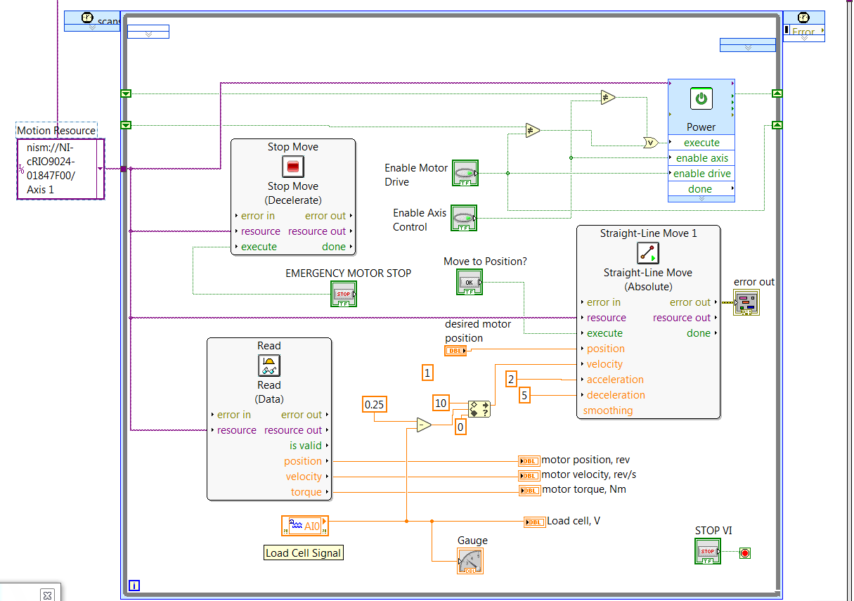

Figure 5.12, Initial LabView code, D. McKean 2017.

Figure 5.12 above shows the original LabView code. The large box on the right labelled ‘Straight Line Move’ is the Virtual Instrument (vi) interface for the servo motor and has its own embedded code on motor dynamics which is populated by the resource code delivered by the purple wire which is taken from the purple box labelled ‘Motion Resource’. This is the code which talks to the Kollmorgen AKD Servo Drive via the NI 9514 servo module onboard the NI Compact Rio target. Down the left side of the Straight Line Move VI, there are inputs for desired; position, velocity, acceleration and deceleration.

## How the Compliant Algorithm Was Expected to Work

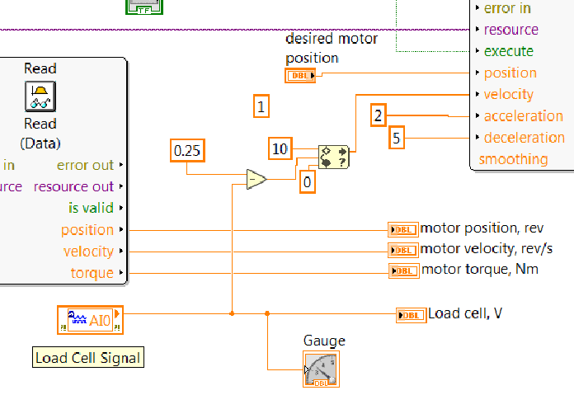

Figure 5.13, Close up of LabView code showing a compliant control algorithm. D. McKean 2017

Figure 5.13 above shows a close up of the compliant control algorithm. The main idea was to use the value from an exogenous force, ideally from a load cell (labelled as such in figure 5.13), but could also be from the motor’s internal torque measurement, to detract from the velocity setpoint (shown as 0.25 in figure 48) which would hold the robot arm while in transit towards its setpoint. When the exo force is removed, the arm is expected to continue towards its setpoint. To prevent negative velocity values entering the motor VI, the velocity input signal was passed through a ‘Limit Block’ which set the minimum value to 0. This approach was tested in many forms, but to no avail. Different versions of motor interface were tested along with using motor torque instead of the load cell. It seemed like no matter what was done, no matter which values were changed during the arm movement, nothing changed.

The random number one in the code does not perform any action.

## Hypothesis as to Why the Compliant Algorithm Did Not Work

It was eventually hypothesised that the motor Straight Line Move embedded code only looked at the input values for desired position and velocity when the code was executed. Anything that happened after the execution, the motor code simply ignored until it had completed its objective. This goes a long was to explain why no compliant control algorithms using LabView’s SoftMotion could be found in any literature.

## Triumph! How Compliance Can Be Created using NI LabView With SoftMotion

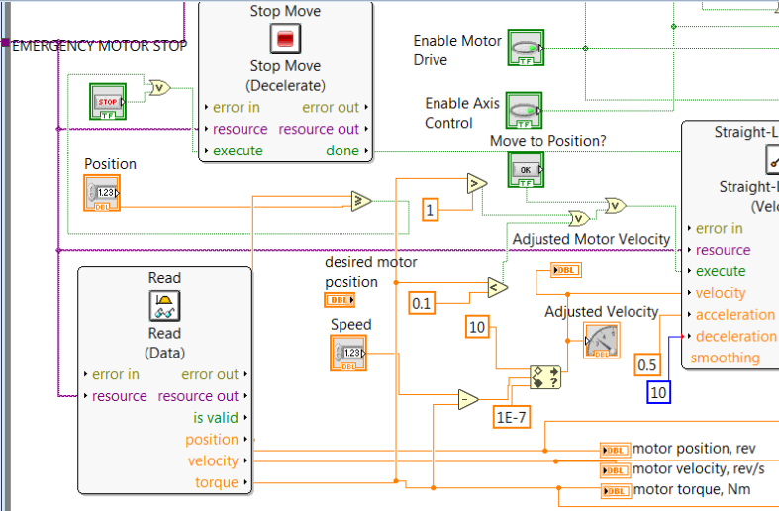

Figure 5.14, Close up view of new working compliant control algorithm in LabView. D. McKean 2017

The code in figure 5.14 above shows how compliant control was eventually realised using NI LabView SoftMotion. It was found that by using Straight Line Move virtual instrument (vi) in ‘Velocity Mode’, different velocities could be commanded even while the motor was still moving from the last command. This means that while the motor is moving towards a setpoint, an external force from ether a load cell or in this case now the motor torque could be used to detract from the velocity slowing the arm down to a stop or even making it move backwards. Moving backwards during a collision could be more beneficial in a human robot collaborative environment as it would prevent the human potentially getting pinned down by the robot. The new problem now was that there was no of setting the desired position setpoint as the input is not available when in ‘Velocity’ mode. To get around this, the motor stop button was utilised. A target position was added via a control input which as fed into a ‘Greater Than’ node along with the actual motor position. Once the motor reached the desired position, the ‘Stop Move’ block would stop the motor. Next came the problem of making the motor move by simply touching it. By having the motor torque fed into ‘More Than’ or Greater Than’ blocks, the torque on the motor itself could be capable of executing the run command on the Straight Line Move block. When the motor sensed an environmental interaction while it was not moving, it would move in the direction of force. The force required to make the arm move could be adjusted in the code and was typically between 0.2 and 1 Nm. If an environmental impact was detected while the arm was in motion, the arm would stop. The torque would detract from the speed setpoint driving the ‘Adjusted Velocity’ to zero until the environmental object had been removed and the arm could continue on its way to the desired setpoint.



Figure 5.15, Video demonstrating the working compliant control algorithm and a Kollmorgen servo motor using NI LabView SoftMotion. D. McKean 2017

The video above in figure 5.15 shows the first working compliant control algorithm on the Kollmorgen actuator. It was clear during testing that some form of gravity compensation would be required to make this system more stable but at least it shows that compliant control can be realised using NI LabVIEW SoftMotion which is thought to be the first time this has been archived. There is a lot of code tiding up to be done and it is anticipated that this code is perhaps not the most elegant way of achieving the desired results as the author has had very little training on using the NI LabView code. This however, has not been allowed to become an obstacle and perseverance has paid off. Further experiments have subsequently been conducted to increase the robustness and repeatability of the system by finding more appropriate ways of implementing some parts of the code.

## Gravity Compensation

Gravity compensation as the name suggests, is the act of adding in control to minimise the effect that gravity has on the mass of an object you want to move. When controlling robotic arms to be compliant, the amount of torque generated at the joints is important for us to know how much force a robot arm is applying when interacting with environmental objects. (Rethink Robotics, 2015)

This control system has been using the torque inferred from the motor current to close the control loop and provide a force feedback. The torque value is used to detract from the velocity setpoint to create a new ‘Adjusted Velocity’. The idea is that when an exogenous force is applied to the robot arm, the motor torque will increase. This increase in torque value is then used to detract from the velocity setpoint driving it to zero and halting the arm. When the exogenous force is removed, the arm is free to continue towards its target setpoint. There is a problem however. When the robot arm is sticking out to the side, 90 degrees to the vertical, gravity applies its own torque of about 0.51Nm. This is above the threshold of the desired exogenous force of 0.2Nm, any more than this and the robot arm tends to push through the impact point which could trap or injure a human in a real-world scenario. Ideally, the exogenous force would be close to zero to have the system be as sensitive as possible to environmental contact, but reducing the force limit to less than 0.2Nm causes instabilities in the system which is suspected to be a result of the motor accelerating creating its own inverse torque effect which when large enough causes the ‘motor-on’ condition to overlap the ‘motor-off’ condition which in turn leads to oscillations, which can be exacerbated by trying to run with too high a velocity. It is suspected that one would need to account for the system inertia to produce a more stable system with a higher bandwidth and this may well be looked at later, time permitting. In order to try and cancel out the effects of gravity, a new piece of code was developed in LabView.

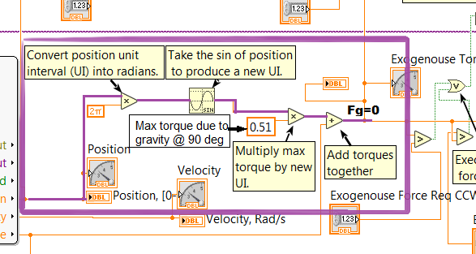

Figure 5.16, LabView code showing gravity compensation, D McKean 2017

Figure 5.16 above shows the new code with gravity compensation. The rout highlighted in purple is where the gravity compensation happens. By converting the motor position which is displayed on the GUI in number of revolutions, (0.5 = half a revolution) into radians by multiplying by 2𝜋 and then passing that value through a sin function, the output is a unit-interval that can be multiplied by the maximum gravitational force value, which at 90 degrees is about 0.51Nm. The max torque product is then added to cancel the actual torque which is negative because the gravitational force is a negative value, pulling the arm down. This relationship is shown in equation 12 below.

|  |  |
| --- | --- |
|  | () |

where motor velocity, $T=$ Torque and $P=$ arm position. Remember that the output value is coerced to within predefined parameters, in this case ± 0.25rad/s, to prevent large torque values causing equally large reverse velocity values. The motor torque can now be cancelled out by subtracting the absolute ‘max torque/position’ product from the actual torque value and any additional torque seen by the controller will now be interpreted as an external force and that force value would then be detracted from the velocity setpoint. Usually when determining gravity compensation, it is normal to find the system dynamics by multiplying the force of gravity by the mass of the object and the distance of the object’s centre of mass (CoM) from the centre of rotation (CoR). What this product gives, is the maximum torque on the robot arm when extended out by 90 degrees. This can be bypass however because the torque determined by the motor current is displayed on the LabView GUI and which can be used to help build the gravity compensation model shown above in figure 5.16.

## Problems Incorporating Gravity Compensation

As mentioned above, the max torque on the robot arm should be at 90 degrees to the vertical, which was found to be about 0.6Nm. This maximum value however did not appear at 90 degrees but instead at about 75 and 105 degrees. The error is very small, on the order of 0.05Nm, but this was enough to cause problems with adjusted velocity value It was first thought that there may be a fault with the motor, but then why didn’t the motor drive flag the fault? It was then realized that the twelve motor poles lie 30 degrees apart and 75 lies between 60 and 90 degrees, meaning that the max torque was lying in between two poles, which just seems wrong. In fact, it was suspected that it was the motor poles that were not perfectly aligned relative to the polar co-ordinate frame. As is shown in figure 5.17 below, the motor is rotated 15 degrees and it is suspected that at 90 degrees the robot arm was between two coils and as such was not subject to as strong a holding current as it could have been if the motor were to be rotated 15 degrees either way. The problem was eventually rectified by simply loosening the arm from the motor’s rotor and rotating it 15 degrees and tightening it back up. Tests later confirmed that the motor arm was not properly aligned at the start of the project but without this subsequent information the arm could not have been aligned anyway.

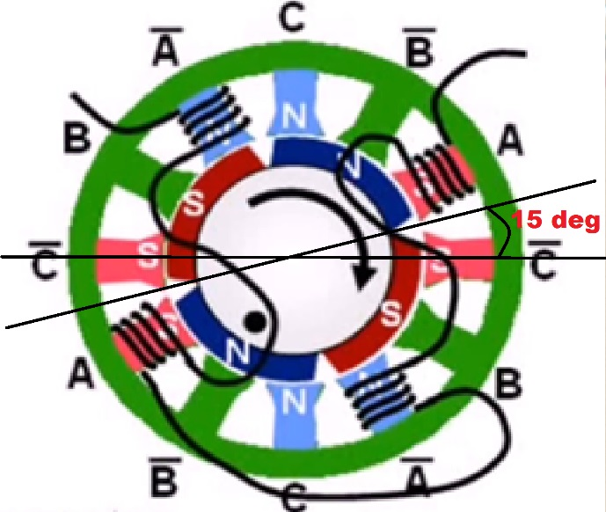

Figure 5.17, 12 poles of the BLDC motor out by 15 degrees relative

to polar co-ordinates. Adapted by D McKean 2017

## Impedance Control Finalisation

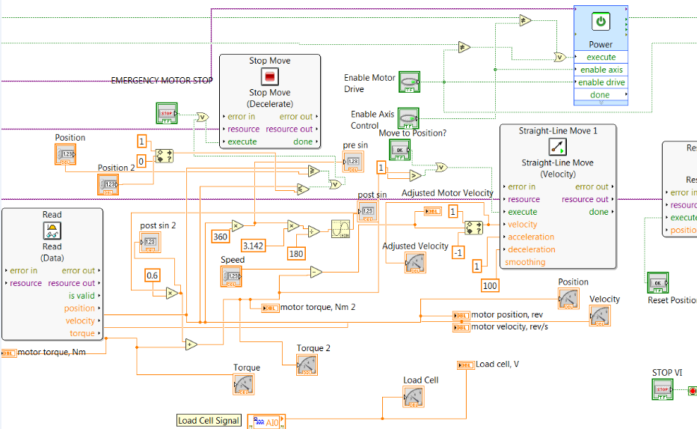

Figure 5.18 LabView code for completed impedance controller. D. McKean 2017

Figure 5.18 above shows the revised development code for the impedance controller which gave very satisfactory results. The code was a little disorganised at this point and is quite hard to read without careful study and it was decided to try and clean it up a bit and add some labelling which will be shown later in the development of the admittance control code in section 5.37. Apart from the gravity compensation that has been mentioned in section 5.34, figure 5.17 shows the code used to stop the robot arm. Two position controls can be seen in the top left of the code, the first labelled ‘position’ sends a value to a ≥ block and if the arm position is ≥ the position setpoint, the block will output a logic 1 which is then passed through two OR blocks to connect other stop signal connected to the ‘Stop’ vi block which then stops the motor. The second control labelled ‘position 2’ sends a value to a ≤ block. If the arm position is ≤ position 2, the block will again output a logic 1 which is sent to the Stop vi, stopping the motor.

On completion of the gravity compensation on the impedance controller, the velocity setpoint is passed through a coercion block which limits the velocity value to ± 1rad/s. When an environmental impact occurs, the exogenous force which has been set to trigger the motor block at forces over 0.3Nm, pulls the velocity setpoint value down to -0.05rad/s which has the effect of making the robot arm back away from the impact point back to some declared position, usually it’s starting point. Once back at the starting point of 0 degrees, the ‘Stop’ code mentioned above stops the motor otherwise it would keep rotating in the reverse direction indefinitely. It was found that just having a setpoint of zero degrees was not sufficient as the motor would often pass through the setpoint while still decelerating at which point the motor would continue in the same direction looking for zero degrees and never finding it. The solution to this was to use the same coercion block as before on the velocity input and have the minimum value for the return position set to zero. This worked well because no matter where the arm eventually came to rest passed the setpoint, it would still be a zero-value halting the motor.

## Admittance Control

With the impedance control working so well, it was thought that maybe it wouldn’t be too much effort to try and adapt the impedance controller code and change it to an admittance controller. To recap, for a force input with admittance control, there is a displacement output. Meaning that an operator should be able to move the robot arm by simply grasping the arm and moving it without any resistance from the motor, irrespective of how high the proportional gain is, which is also described as stiffness in controlled mechanical linkages, meaning that mechatronic systems with very high proportional gain will feel very stiff, like a stiff spring, whereas low proportional gain will cause an actuator to feel softer. The motor is very stiff due to the holding torque while the admittance controller is not active, but upon activation, the controller is able to sense any external force >0.3Nm equivalent to about 30 grams acting on the robot arm and is able to drive the motor with the arm in the direction of and proportional to the external force. Achieving admittance control was relatively simple thanks to the similarity to the impedance controller. The only real change made to the impedance controller to produce an admittance controller was to have the velocity setpoint set to zero and have the exogenous force multiplied by a gain in order to control the effect the force has on the velocity. The force is then added to the zero setpoint to produce an adjusted velocity value proportional to the exogenous force applied to the arm. This contrasts with the impedance controller where the force was being subtracted from the positive velocity value to slow the arm down. In this new admittance controller, the goal is to speed the arm up in the presents of external forces.

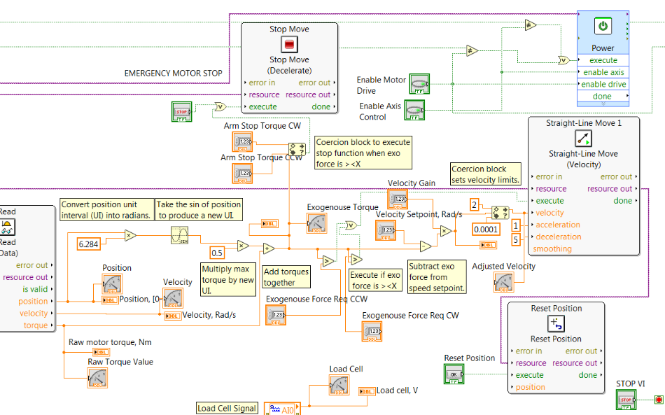

Figure 5.19, Admittance controller LabView code, D. McKean 2017

Figure 5.19 above shows the LabView code developed for the Admittance controller. All the code has now been organised and labelled to help with understanding the structure and logic behind the code. The code for the loadcell is not currently used and is disconnected from the rest of the system. The ‘stop’ function as also been changed to operate when the exogenous torque is within a set range of ≥ - 0.2Nm and ≤ 0.2Nm. The ‘Straight line Move’ vi is executed when an exogenous torque of ≥ 0.3Nm or ≤ - 0.3Nm is detected. This bit of code is also controlled by a pair of control inputs on the GUI but are also visible on the code as ‘Exogenous Force Req’ clockwise and anticlockwise. In order to allow the arm to move backwards, the velocity setpoint mush allow negative numbers. -2 was mainly used as the minimum value for this control, although in the code above, the minimum value is set to 0.0001. this was because compliant control in just one direction was being used. The value of 0.0001 was used because the code does not recognise the zero figure. This took a while to realise.



Figure 5.20, Video showing admittance controller. D. McKean 2017

Figure 5.20 above shows a video of the admittance controlled actuator in action. It can be seen in the video how by just applying a small input force, the arm becomes very compliant and moves in the direction of the applied force. It almost looks like the motor is switched off and that the friction of the bearing is what is keeping the motor in position, but this is definitely not what is happening, nor is the motor being forced into position against the motor holding torque as this would very quickly overload and destroy the motor. The controller is driving the motor in the direction of the force at a speed proportional to the exogenous force. This will be proven in a subsequent video in section 5.38 on hybrid control.

## Hybrid Compliance

It was seen from chapter 5.12 that admittance control can be achieved by carefully rearranging some components of the impedance controller. In this chapter, the report will look into combining these two control strategies to produce a hybrid compliant control strategy in order to achieve the benefits of both systems.

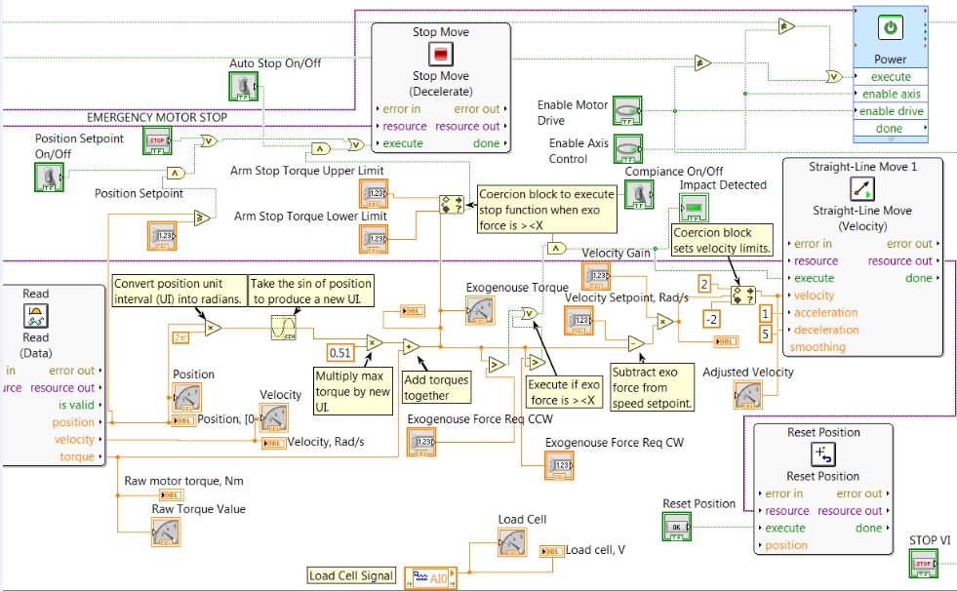

Figure 5.21, LabView code for the Hybrid Controller. D. McKean 2017

Figure 5.21 above shows the new LabView code developed for the new hybrid controller and figure 5.22 below shows the LabView GUI for the control. This new control architecture features three flick switches shown in figure 5.21 which can turn on the ‘Automatic Stop’, the ‘position Setpoint’ and even turn off the ‘Compliance’ completely. The switching of the compliance demonstrates that the system is stable even when switching between two control methods in real time. This was achieved by having a switch ANDed into the Straight Line Move vi execution terminal. When the switch is off, no execution logic can pass through to the Straight Line Move vi. The Position Setpoint switch controls whether the arm moves to a setpoint when activated or simply spins indefinitely when deactivated. Again, this was achieved by having the switch ANDed into the Stop logic. The Auto Stop/Start switch controls whether the arm stops when there is no exogenous force present. This has the effect of allowing the robot arm to move in the opposite direction when a collision is detected. The arm can then either keep rotating indefinitely backwards or move back to a setpoint. This was also achieved by having a separate switch in the Stop logic that switched off the signals coming from the Auto Stop/Start coercion block.

Hybrid control was achieved by setting the velocity setpoint to an arbitrary value and having the position setpoints switched off. Auto Stop/Start was also switched off or this would be contradicting the velocity setpoint. The velocity coercion block now has a minimum value of -2rad/s meaning that the arm can move backwards, as with the admittance controller.

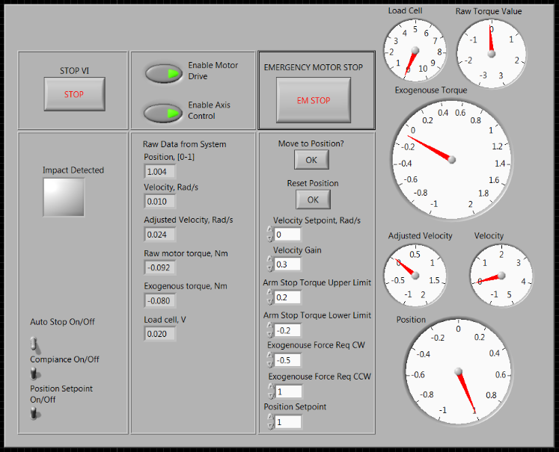

Figure 5.22, LabView GUI for hybrid controller. D. McKean 2017



Figure 5.23, Video showing the new hybrid controller in operation. D. McKean 2017

Figure 5.23 above is a video showing the new hybrid controller in action. To start, a small force initiate movement and the arm begins to rotate. Once rotating, the arm meets an environmental object. The contact between the arm and the object produces a torque of 0.2Nm. This torque is read by the controller which then commands the arm to move in the opposite direction by applying a negative velocity. Once the arm loses contact with the environmental object, the torque value drops to zero which then resets the arm velocity to its original value and it continues rotating. This is demonstrating impedance control. For a speed or angle input, there is a force output. If the torque from the environmental object remains while the arm is moving backwards, the arm will continue to move backwards as can be seen in the video when the hand is pushing the arm away. This is now admittance control. For a force input from the hand, there is a position output. Once the hand stops pushing, the arm is again free to rotate.

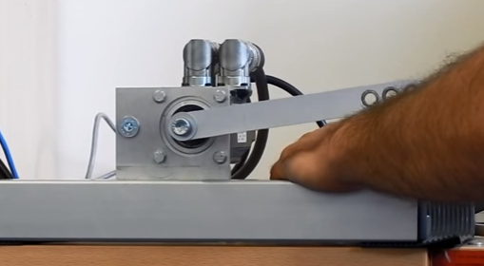

Figure 5.24, Shows robot arm meeting an environmental object. D. McKean 2017

Figure 5.24 above is a picture of the robot arm contacting an environmental object just before being pushed away by the hand.

## A Discussion on The Compliant Control of Conventional & Electrically Assisted Turbocharges

So, what is the best control strategy for modelling new turbos using electrified turbocharges, impedance, admittance or both? In the case of modelling different sized turbos, it is required be able to make a vehicle engine think that the turbo it has fitted to it is either larger or smaller than it actually is. In the case of modelling the engine and turbo at high altitudes it is required to mimic the effect of less oxygen being available for the engine to suck in due to the thinning atmosphere at high altitude. One way of possibly achieving this may be to control the acceleration of the electric motor giving the impression of a larger inertia. Small turbos have a small inertia and therefore spool up rather quickly, larger turbos will take longer to spool up. One problem that is foreseen with this idea is the problem of mass air flow (MAF). Although a large turbo will take longer to sloop up, once it has spooled up there should be a relatively large air flow and that may be difficult to achieve as the orifices of a physically smaller turbo will be of a set size. A possible solution to this may be the use of a secondary supplementary turbocharge to provide the extra air. This supplementary turbo will have to be controlled externally and the MAF calculated on the predicted MAF of the larger modelled turbo. One thing that has since become apparent while writing; is that this paper has not been explicit about which type of turbocharger are trying to be modelled and that it could be inferred that it is different sizes of electric turbo are trying to be modelled. But this is definitely not the case as there is no point modelling different sizes of electric turbos because they can be controlled to operate at any speed at any engine condition and so the size of the turbo becomes irrelevant as long as it is large enough to move the maximum air mass at its top speed.

Modelling different sizes of conventional turbos using compliant control? Conventional turbochargers and perhaps even superchargers (air compressors that are driven directly from the engine), have a fixed geometry and their compressor speed is directly proportional to the speed of the exiting exhaust gasses flowing through the turbo’s turbine. So, applying some electrical energy to drive a model of a conventional turbo would have the effect of reducing the turbo’s apparent inertia, making it seem lighter and quicker at spooling. A controller can already drive a turbo using an electric motor, so is compliant control needed? At steady state, there is a set turbo speed delivering a fixed amount of air mas and so it is not hard to find out how much electrical energy is required to reduce the apparent inertia of the turbo to zero. Electrical energy can be added until the exhaust back pressure is equal before and after the turbine, meaning that the waste exhaust gas is not applying any torque by not having to impart any of its energy into the turbine to keep the turbo spinning a constant velocity because the turbo is being solely being driven by the electric motor. Now the controller can reduce the amount of electrical energy being supplied anywhere between zero and the maximum required for zero inertia. This is thought to produce a physical model of a turbo that is smaller and therefore lighter than the original and the difference in air mass could be controlled with a throttle plate in the air intake path.

For modelling turbos larger than the original, the motor will need to apply a force to slow the turbo down to a speed below its normal operating speed for a particular engine condition. By applying a small reverse current through the motor, the torque can be increase between the exhaust gas and the turbine making the turbo seem larger and stiffer as the compressor tries to suck in and compress more fresh air and also overcome greater friction as the larger normal force acting on the bearings increase the frictional losses in the system. In fact, extra resistance could also be added to the electric motor circuit in the form of a battery and have that apply the reverse torque while charging the battery.

Compliant control is not required for the above steady state condition as nothing is changing. But what about transient conditions? During acceleration, the amount of air entering and leaving the engine is changing and so this may be a candidate for compliant control. During engine acceleration, the waste exhaust gases apply a torque to accelerate the turbine. This torque sensed by the motor as an increase in current could be used as a direct measurement to alter the speed of the electric motor used to drive the turbo. It would be difficult to determine the varying torque required to produce the desired stiffness in the turbo at every speed and condition, but with compliant control automatically varying the applied torque based on the force exerted by the exhaust gases there is a direct way of achieving the goal.

## Compliant Control for Electrically Assisted Turbocharges for Increased Efficiency

In section 5.14 above it was noted that compliant control was not needed to drive an electrified turbocharger as the turbo can already be controlled to spin at whatever speed is desired at whatever engine condition. But what if the electric turbo could increase its efficiency? As discussed in the final paragraph of section 5.14 it was found that if you monitor the force of the exhaust gases on the turbine, a compliant controller could vary the amount of electric assistance, on demand. This means that the amount of electrical power needed can be directly proportional to the force applied at the turbine at any speed and engine condition as opposed to applying maximum current to drive the turbo electrically just to overcome lag.

## Implementation of a Possible Compliant Turbo Control

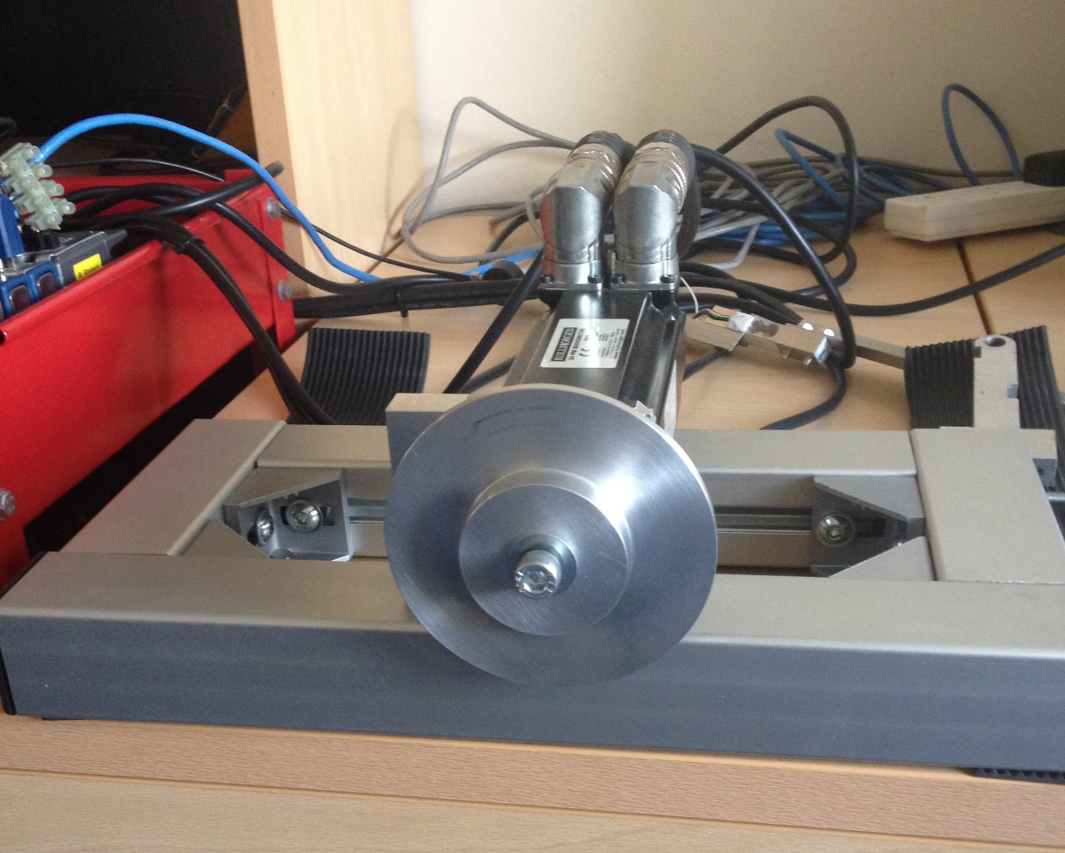

Figure 5.25, Servomotor with disc fitted. D. McKean 2017.

Figure 5.25 above shows the servomotor with the arm removed and a solid aluminium disc fitted in its place to simulate the turbine on a turbocharger. The disc was turned up by the author on a manual lathe in one of the mechanical workshop at Loughborough University using a piece of 4” aluminium billet. It was made thick enough hold but also to be as light as possible in order to fully show the difference in changing the apparent inertia of the disc.

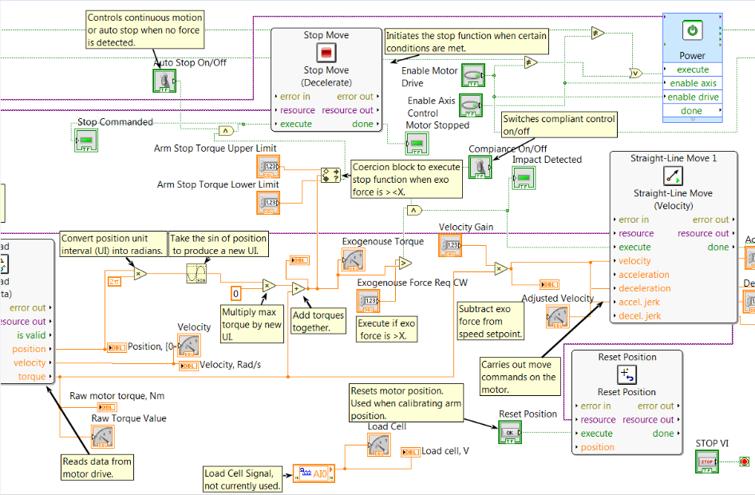

Figure 5.26, Compliance code for turbo model. D. McKean 2017

Figure 5.26 above shows the LabView code developed to run a turbo model using an aluminium disc. The difference between this and previous code is that the gravity compensation value has been reduced to zero which eliminates all compensation code preceding it. This is because gravity compensation is not needed on a uniform circular disc. As the turbo should only spin in one direction; the exogenous torque measurements have been reduced to just one for the forward direction. Also, because of only moving in the forward direction, the velocity coercion block has been removed to help simplify the code. Having the turbo stop at a specific position is not importance and so code built to stop the motor at specific positions has also been removed and all the control is done just from the torque feedback value.

The operation of the code is as follows: The velocity setpoint is set to zero. When an exogenous force is felt by the motor, the disc will start to rotate at a speed relative to the amount of torque applied multiplied by the velocity gain. The change in apparent inertia is achieved by altering the acceleration and jerk of the Straight Line Move vi. Having the disc accelerate at a maximum of 10 $m/s^{2}$ with a jerk of 5 $m/s^{3}$ gave a realistic feel of a lightweight disc being spun up by hand. The deceleration values were found to give realistic looking effects when set to half of the acceleration values. This gave the impression that the disc was slowing down as a result of low friction in the bearing but is in fact all controlled by the motor controller. Using values of $1m/s^{2}$ and $0.1m/s^{3}$ for the acceleration and jerk respectively gave the impression of a very heavy flywheel which took a long time to get moving and also took a long time to slow down. In both of these cases, the velocity was only increasing as long as an exogenous torque was detected by the motor, otherwise the disc would slow back down.



Figure 5.27, Video of Admittance controlled disc representing a turbocharger. D. McKean 2017

Figure 5.27 above shows a video of this controller in action. The first part shows a high inertia wheel followed by the second part showing a very low inertia wheel.

## Limitations of Compliant Control

Further to the discoveries in chapter 21.5, the windings of the motor although designed and build to the highest standards do not produce a consistently uniform magnetic field around the motor and therefore the torque is also not perfectly uniform. Experiments showed that as the robot arm is slowly moved from 0 to 180 degrees with the admittance controller, the torque value on the motor fluctuates between 0 and 0.2Nm. The pattern of fluctuations was shown to be every 15 degrees which correlates to the positioning of the BLDC motor windings which are spaces 30 degrees apart. At 30 degree intervals, the maximum magnetic field is felt by the motor rotor, but when 15 degrees out of phase; the minimum magnetic field is present. It is thought that this is the main limitation when it comes to trying to fine tune the compliant controller for very delicate or light interactions that give a torque of 0.2Nm or less. Why would anyone need a compliant controller this sensitive? More haptic devices are finding their way into hospital operating theatres for procedures such as keyhole surgery (Force Dimension, 2017) (ImmersiveTouch Inc., 2017).

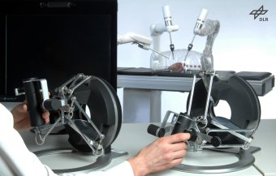

Figure 5.28, Showing the use of a surgical haptic device. DLR 2017

Figure 5.28 above shows a surgeon practicing with a haptic device. Compliant control for procedures such as this need to be very delicate and sensitive to the patient’s body as not to cause unnecessary harm and also be able to filter out vibrations or jerks from the surgeon’s hand movements. Having incredibly sensitive compliant actuators could also help produce exoskeletons that so sensitive to external forces that the wearer is unaware that they are even wearing it.

# Chapter 6, Conclusion, A Review of What Has Been Achieved Plus Future Applications and Further Possible Work

The achievements of the practical implementation of these control algorithms are, for the case of the robot arm;

* Compliance in forward, backward or both directions.
* Variable compliance in different directions.
* Reverse compliance. (Moving towards force input).
* Both impedance and admittance control in the same controller creating a hybrid controller.
* Understanding of the limitations of low torque compliant control using brushless DC electric motors.
* Discovering the motor’s own inbuilt current sensor to measure torque works very well, eliminating the need for external torque sensors and loadcells.

In the case of the electrified turbo model;

* Using admittance control to change in the apparent inertia of the turbo model.
* Discovering that compliant control could potentially work on electrified turbocharges to help increase efficiency and not just to model conventional turbos.

Overall, this project has been very successful and a great deal of new information has been realised particularly in the limitations of compliant control. To confirm the findings here, further tests should now be carried out on a replacement motor and drive, and then using other motors to see if the same results are achieved. The industrial advisor and other academics at Loughborough University are also very pleased with the results of this project and have suggested that a research paper be written on the subject, particularly due to the fact that on one has yet been able to create compliant control using NI Softmotion®. Also, due to the undertaking and successful completion of this project, the author has been given the chance to embark upon a PhD at the Intelligent Automation Group at Loughborough University.

## Impedance Controlled Turbocharger

One of the main application for which this work is intended is on the new Electrically Assisted Turbocharger developed in part by Loughborough University. Future work will include incorporating the new admittance control algorithm into the control structure of the turbo to test certain new ideas such as modelling different sized turbocharges by either electrically helping the turbo to spool up quicker, simulating a smaller turbo with a smaller inertia or by electrically impeding the turbo, simulating a large turbo with a larger inertia. Other ideas are to simulate changes in altitude. It is thought that an engine’s turbo at high altitude with have less air to compress as the air is thinner higher up in the mountains causing reduced power and that impeding the turbo at sea level could simulate this effect which could help to engineer solutions to this problem at high altitudes. It is also thought that the electric turbo itself could benefit from compliant control by increasing its efficiency by only supplying enough power to the turbo to reduce the inertia to zero and no more.

## Human Robot Collaboration

It is hoped that this work on compliant control will continue with work on human robot collaboration. Although compliant control currently exists, there is still a real need to increased bandwidth and efficiency, having the robot react quicker to environmental impacts and move in such a way as to dissipate the kinetic energy without harming the human collaborator. The ideal solution to an exoskeleton would be a system where the human was completely unaware that they were even wearing the robot while at the same time giving the human almost super human abilities, such as lifting heavy weights repeatedly, or running quickly for many miles.

# Appendix I, Personal Reflection on Report

This project has been very emotional. On one hand, it has been one of the best things I have ever achieved, a fitting end to the past six years of study I have embarked upon, but on the other, it has been one of the most physical and mental challenges of my life and I’ve been a Royal Marine! It was grossly underestimated just how much would need to be learned in order to achieve the goals set out in this project, just to be able to read and understand the research papers on the subject required a great deal of Linear Algebra review. The amount of time needed, although it was assumed to be very high from the beginning was much higher than anticipated. Family problems have played a very prominent role and have plagued this project right from the beginning which have prevented me from attending college and spending as much time as I would have liked studying. Luckily, Derby University have been exceptional in trying to help with my very convoluted and stressful issues and for that I am eternally grateful. Found below in appendix I, there is the MS Project Gantt chart that was hoped to be the corner stone of this project, breaking the whole project up into small achievable chunks and setting goals to aim for. This, along with other study plans that were set out did not last long, as where and when I got chance to do any studying or research on this project get ever more unpredictable. During work, I could spend my half hour dinner break, if I got one that day, on trying to get my Kollmorgen servo motor set up with all the right software and licences which literally took months even with the help of the school IT manager Rob Flint, to whom I also owe a great deal of thanks. At home, once the kids were fed, washed and tucked up in bed, which usually took until about 10 O’clock at night, I would work until around 2am working on this project and my other concurrent Innovation module. Bringing this all back into context; I found it incredibly difficult to organise myself amidst everything that was going on at the time. If I hadn’t have been signed of work for two weeks by my doctor I would have never been able to submit my original dissertation on time, even though it was not even half completed. My original report only consisted of the mathematical modelling in Matlab and even that didn’t hold up to scrutiny by the examiner from derby Uni during my viva. I was very ill prepared for my original viva, I didn’t fully understand the subject matter but I tried as best I could to explain what I was trying to achieve and how I was planning to achieve it. The derby examiner made a point of showing me that I was wrong in every way which I kind of already knew myself but it still felt very humiliating. This was all happening while amongst other things, my dad was dying of cancer and so I didn’t put on a very good show. If I knew at the start what I know now, I would have chosen a much simpler topic for my final year project, something that didn’t need quite as much learning beforehand. Although, if it were not for the subject of this project, I would not soon be embarking on a PhD in the subject of Human Robot Collaboration at Loughborough University. This is all dependant of course on the outcome of this project.

This Project was chosen from a list of MSc projects offered in the department of Aeronautical and Automotive Engineering at Loughborough University, chosen mainly because I was so interested in control theory and wanted to do something that would channel my interests and enthusiasm. In an ideal world, I would have spent more time organising myself and researching just what would be required in each of the projects listed to have a better idea of what I was letting myself in for. I should have picked a project that utilised what I already knew and what I had been taught while at college.

# Appendix II. Further Attempts at Gravity Compensation

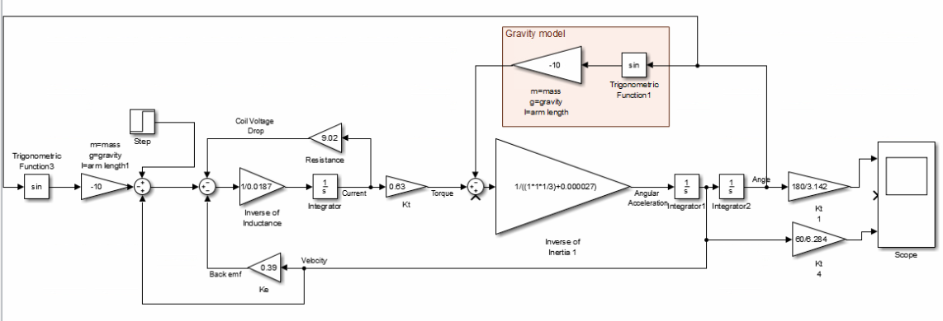

Figure 8.1, Attempting to fix gravity compensation problem in Simulink model. D. McKean 2017

Figures 8.1 and 8.2 show an attempt to try and fix the ongoing problem of applying gravity compensation the original Simulink model. This problem seemed to have a solution just around the corner but other aspects of the model kept preventing the model from working correctly. It is still not known how to pass the compensation value through the motor without the dynamics of the motor distorting the signal.

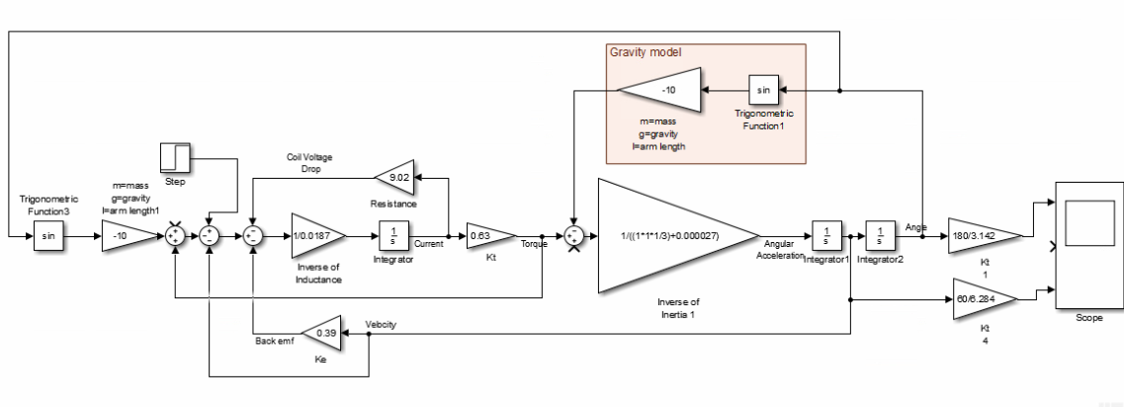

Figure 8.2, Gravity compensation using torque feedback from motor. D. McKean

It was thought that maybe if the gravity compensation signal is getting distorted by the motor dynamics, then perhaps adding motor torque feedback to the gravity compensation value would correct for it. This did not work either and the decision was taken to scrap the idea of adding gravity compensation to the Simulink code in favour of completing the report. After this report, there will be further reading on gravity compensation to help fill this important controls gap.

# Appendix III, MS Project Gantt Chart

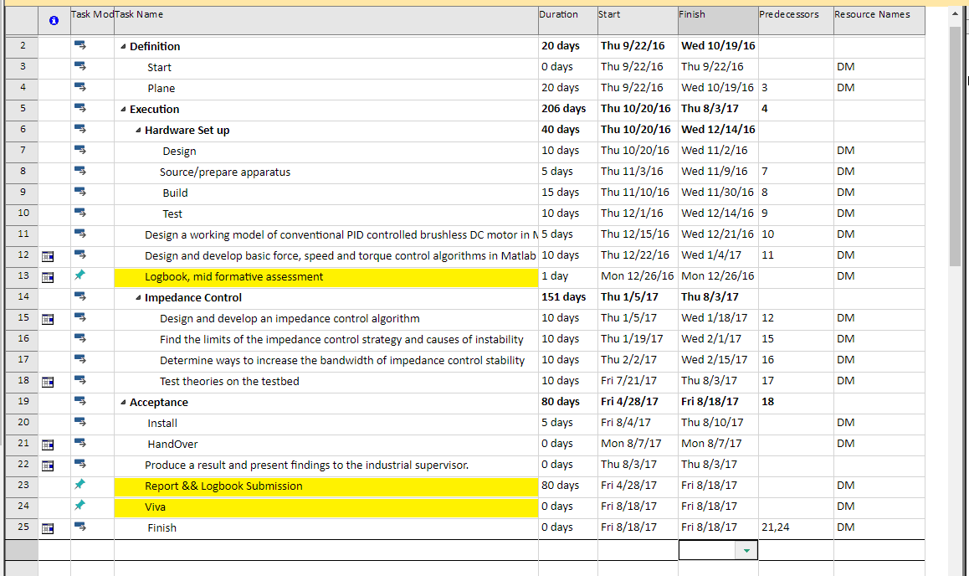

Figure 9.1, Project Gantt Chart of Compliant Control project. D. McKean 2017

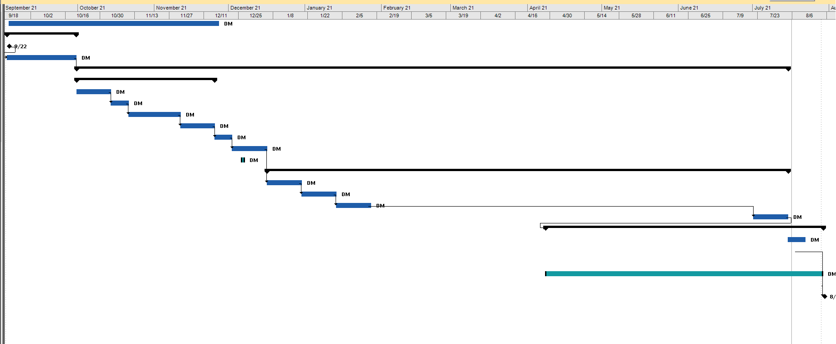

Figure 9.2, Gantt Chart of Compliant Control Project. D. McKean 2017

Figure 9.1 and 9.2 above shows the MS project Gantt chart used in this project. The original plan was for MS Project to be used throughout this project to help keep on course by providing waypoints and targets to try and achieve just a small portion every day. As with a lot of the planning that when into this project the use of this Gantt chart didn’t last long. A longer explanation as to why this happened is included in the Personal Reflection in Chapter 5.20.

# Appendix IV, Previous LabView Code from Early Attempts at compliant code

Below is a selection of code snippets from the early LabView code while trying to develop impedance control.

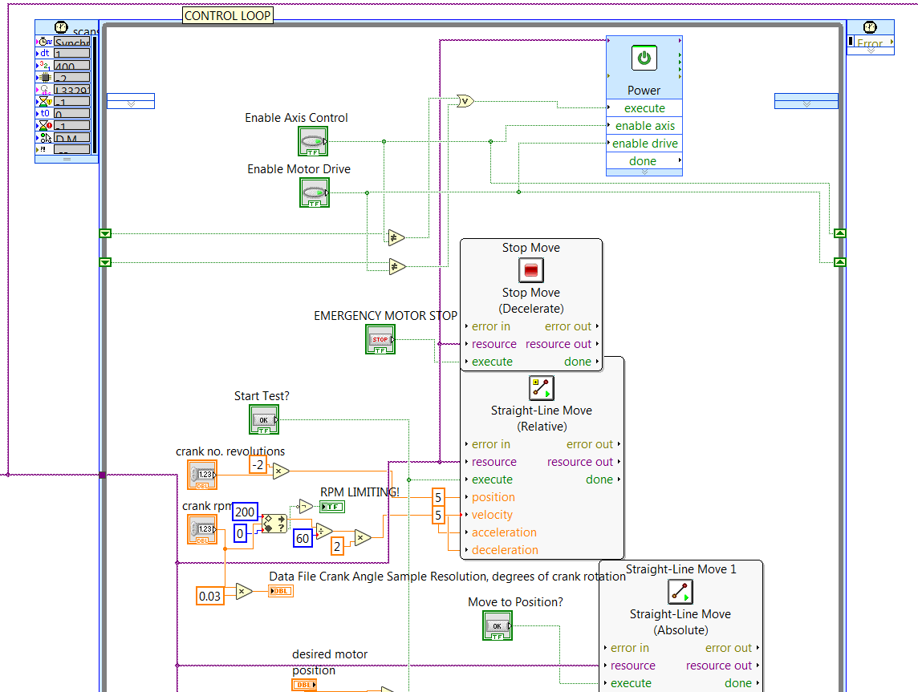

Figure 10.1, Impedance Control code 1, D. McKean 2017

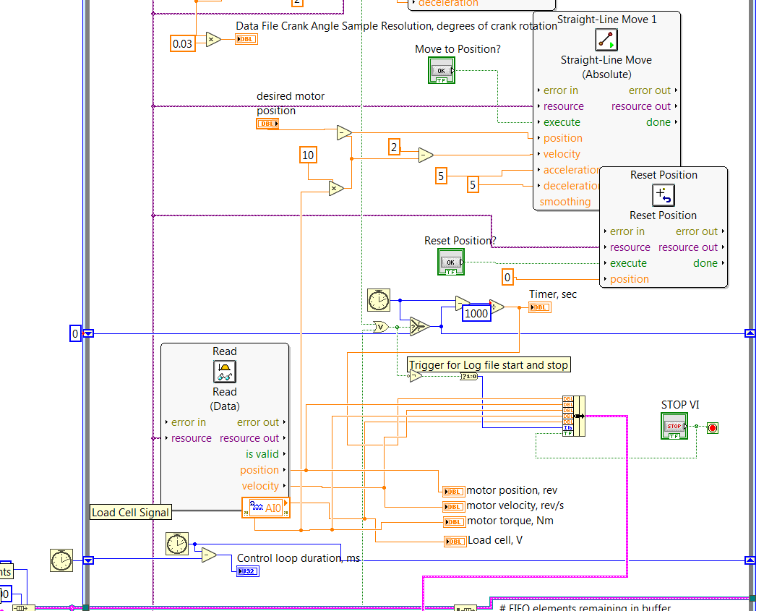

Figure 10.2Impedance control code 2, D. McKean 2017

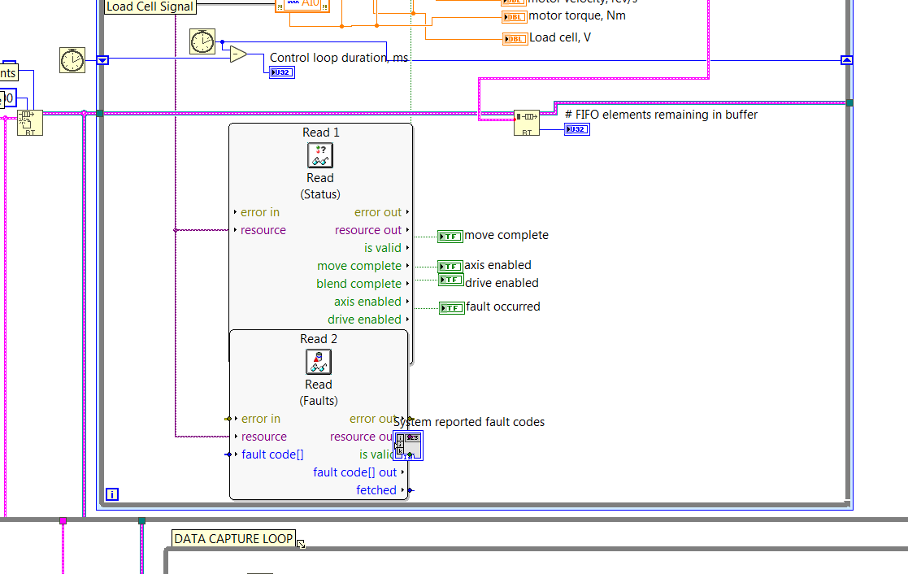

Figure 10.3, Impedance control code 3, D. McKean 2017

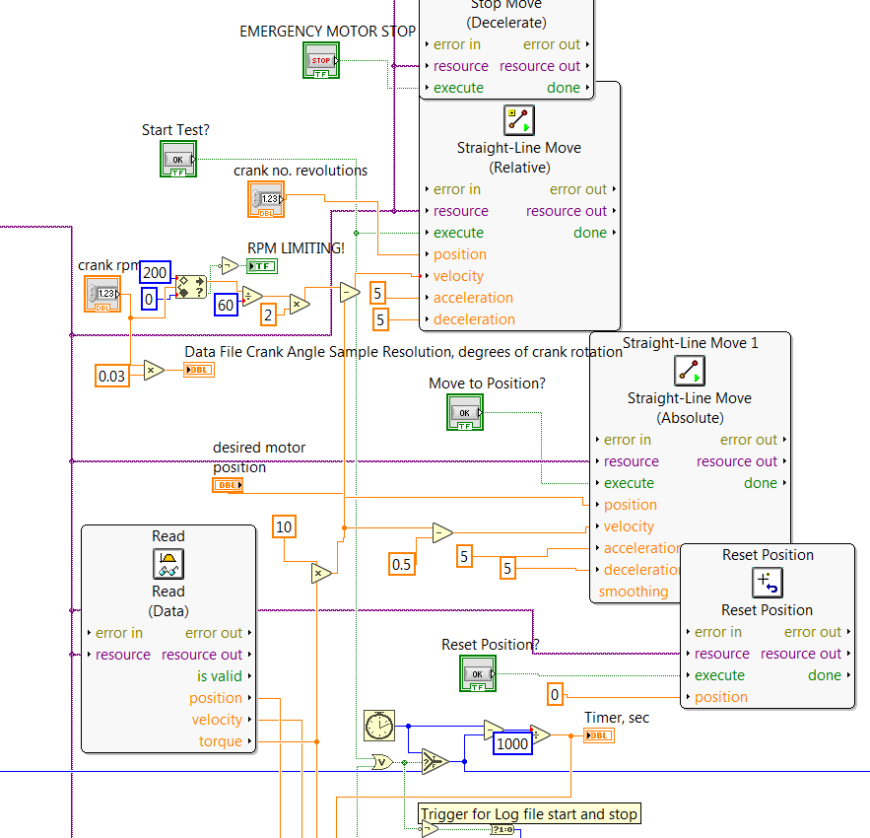

Figure 10.4, Impedance control code 4, D. McKean 2017

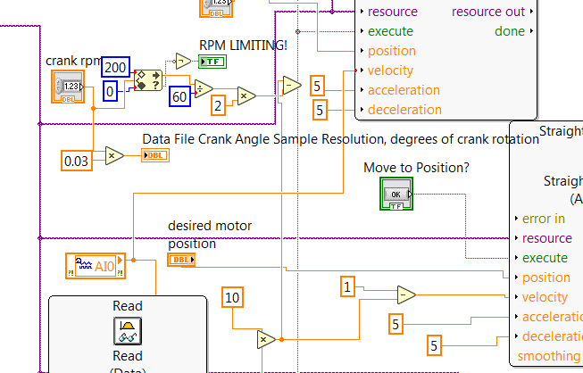

Figure 10.5, Impedance control 5, D. McKean 2017

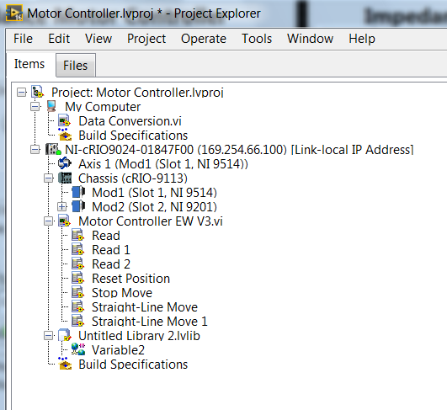

Figure 10.6, LabView project, D. McKean 2017

# Appendix V, Kollmorgen AKM24 Servo Motor Technical Specification

Features

* 8 frame sizes, 28 frame/stack combinations
* Speeds up to 8,000 RPM
* 75 VDC; 120, 240, 480 VAC windings
* A wide variety of feedback devices, mountings and seals
* Direct mate to most Kollmorgen servo drives
* Windings are rated at 100°C rise over a 40°C ambient while using 155°C (class F) insulation materials
* cURus, CE Compliant, UL Recognition

Options

* Feedback devices: resolver, SFD, incremental and sine encoders
* Seals for improved environmental protection
* Shaft ends closed or open keyway, flat, smooth
* Dual or single Intercontec connectors, straight or rotatable
* 24 VDC fail-safe brakes
* IP67 washdown versions with food-grade greases and finishes

Benefits

* Unprecedented choice and flexibility from a wide range of standard products and co-engineered modifications for an exact fit to your design requirements
* Best-in-class performance, with industry-leading power density
* Exceptionally low cogging and low harmonic distortion to ensure smooth performance
* Easy to commission and use, with plug-and-play motor recognition and full-frequency autotuning on AKD™ Series servo drives

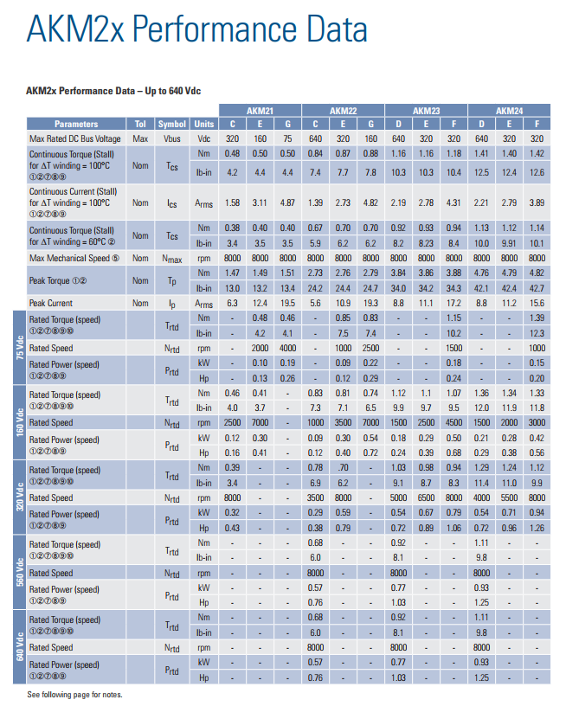

Table 11.1, Part 1 of Kollmorgen AKM24 datasheet (Kollmorgen, 2014)

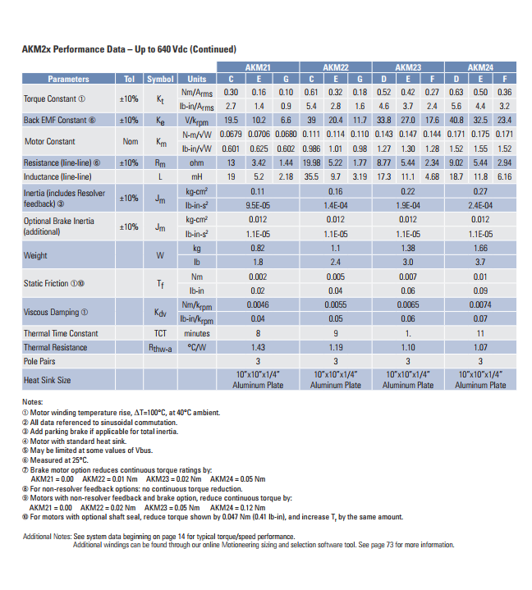

Table 11.2, Part 2 of Kollmorgen AKM24 Datasheet (Kollmorgen, 2014)

# Appendix VI References

Abdallah, M. & Kennedy, K., 2013. Advanced Monitoring and Control of Anaerobic Digestion in Bioreactor Landfills. *Intechopen.com.*

Adams, R. J. & Hannaford, B., 1999. Stable Haptic Interaction with Virtual Environments. *IEEE TRANSACTIONS ON ROBOTICS AND AUTOMATION,* 15(3), pp. 465-474.

Anderson, S., Soderberg, A. & Bjorklund, S., 2006. Friction models for sliding dry, boundary and mixed lubricated contacts. *Tribology International,* Volume 40.

Ang, K. H., Chong, G. & Li, Y., 2005. PID Control System Analysis, Design, and Technology. *IEEE TRANSACTIONS ON CONTROL SYSTEMS TECHNOLOGY,* 13(4), pp. 559-576.

Apptronic, n.d.. *Series Elastic Actuators from Apptronik.* [Online]   
Available at: http://www.apptronik.com/products/series-elastic-actuators/  
[Accessed 13 08 2017].

Astrom, K. J. & Hagglund, T., 2001. The future of PID control. *Elsevier Science Direct,* 9(11), pp. 1163-1175.

Astrom, K. J. & Murray, R. M., 2010. 8: Transfer Fuctions. In: *Feedback Systems, An Introduction for Scientists and Engineers.* Princeton: Princeton University Press, pp. 248-282.

Bigge, B. & Harvey, I. R., 2007. Programmable springs: Developing actuators with programmable compliance for autonomous robots. *Robotics and Automomous Systems.,* 55(9), pp. 728-734.

Boaventura, T. et al., 2013. Stability and Performance of the Compliance Controller of the Quadruped Robot HyQ. *IEEE/RSJ International Conference on Intelligent Robots and Systems.*

BorgWarner, 2017. *History.* [Online]   
Available at: http://www.turbos.bwauto.com/products/turbochargerHistory.aspx  
[Accessed 16 01 2017].

Bryant, M. D., 2008. *ME 344, Dynamic Systems & Control, Spring 2008, Laplace Transforms & Transfer Functions.* [Online]   
Available at: http://www.me.utexas.edu/~bryant/courses/me344/DownloadFiles/LectureNotes/Laplace+TransferFunctions.pdf  
[Accessed 01 12 2016].

Calais Turbo, 2017. *History of The Supercharger.* [Online]   
Available at: http://www.calaisturbo.org/history-of-the-supercharger.php  
[Accessed 31 05 2017].

Calanca, A., Muradore, R. & Fiorini, P., 2016. A Review of Algorithms for Compliant Control of Stiff and Fixed-Compliance Robots. *IEEE/ASME Transactions on Mechatronics,* 21(2), pp. 613-624.

De Schutter, J. & Van Brussel, H., 1988. *Compliant Robot Motion,* Heverlee, Belgium: Katholieke University.

Force Dimension, 2017. *Medical Devices.* [Online]   
Available at: http://www.forcedimension.com/products/medical/overview  
[Accessed 04 08 2017].

Force Robots, 2017. *Grinding.* [Online]   
Available at: http://www.forcerobots.com/applications/grinding/  
[Accessed 2017 08 12].

Garber, G., nd. *Energy in a Pendulum.* [Online]   
Available at: http://blogs.bu.edu/ggarber/interlace/pendulum/energy-in-a-pendulum/  
[Accessed 19 02 2017].

Glueck, E., 2013. *Introduction to Brushless DC (EC) Motor and Gearmotor Technology.* [Online]   
Available at: https://gearmotorblog.wordpress.com/2013/08/06/brushless-dc-gearmotors/  
[Accessed 05 02 2017].

Hiesmair, L., 2016. *Compliant Exoskeleton.* [Online]   
Available at: https://static1.squarespace.com/static/559921a3e4b02c1d7480f8f4/t/585c6a4c9f7456836c12bf3f/1482451537858/Hiesmair.pdf  
[Accessed 13 08 2017].

Hogan, N., 1985. Impedance Control: An Approach to Manipulation. *Journal of dynamic systems, measurement, and control,* Volume 107, p. 17.

Ibarra, J. C. P. & Siqueira, A. A. G., 2014. *Impedance Control of Rehabilitation Robots for Lower Limbs. Review.* [Online]   
Available at: https://www.researchgate.net/publication/267623885_Impedance_Control_of_Rehabilitation_Robots_for_Lower_Limbs_Review  
[Accessed 01 08 2017].

ImmersiveTouch Inc., 2017. *Medical devices interact with tissue using haptic feedback.* [Online]   
Available at: http://www.immersivetouch.com/technology_and_services_feel.html  
[Accessed 04 08 2017].

InnovationTool.com, 2013. *Creative thinking technique: Lotus Blossom.* [Online]   
Available at: http://www.innovationmanagement.se/imtool-articles/creative-thinking-technique-lotus-blossom/  
[Accessed 22 October 2016].

Ishida, T. & Takanishi, A., 2006. *A robot actuator development with high backdrivability, IEEE, Robotics and Automation Conference.* s.l., IEEE.

Kazerooni, H., 1990. Human-Robot Interaction via the Transfer of Power and Information Signals. *IEEE Transactions on Systems, Man and Sybernetics,* 20(2), pp. 454-455.

Kleijn, C., Groothuis, M. A. & Differ, H. G., 2011. *20-sim 4.2 Reference Manual.* s.l.:Controllab Products B.V..

Kollmorgen, 2014. *AKM2x Performance Data.* [Online]   
Available at: http://www.raveo.cz/sites/default/files/dokumenty/%5Bkatalog%5D_Kollmorgen_AKM_Selection_Guide_2014_EN.pdf  
[Accessed 01 09 2016].

Lawrence, D. A., 1988. Impedance Control Stability Properties in Common Implementations. *IEEE.*

Leibniz, G. W., 1698. *On Nature Itself, or on the Inherent Force and Actions of Created Things.* s.l.:Springer Link.

Machinerylubrication.com, 2016. *The Right Way to Lubricate Worm Gears.* [Online]   
Available at: http://www.machinerylubrication.com/Read/30388/lubricate-worm-gears  
[Accessed 13 08 2017].

Magallanes, Y. & Sánchez, J. A., 2015. A pattern-based approach to activity design in creative work supported by surface computing. *IEEE, Electronics, Communications and Computers (CONIELECOMP), 2015 International Conference on,* 16 April.

Makkar, C., Dixon, W. E., Sawyer, W. G. & Hu, G., 2005. *A New Continuously Differentiable Friction Model.* Monterey, California, USA, s.n.

Melchiorri, C., nd. *Dynamic model of robot manipulators.* [Online]   
Available at: http://www-lar.deis.unibo.it/people/cmelchiorri/Files_Robotica/FIR_05_Dynamics.pdf  
[Accessed 19 02 2017].

Mindjet, 2016. *WWW.mindjet.com.* [Online]   
Available at: https://www.mindjet.com/  
[Accessed 19 November 2016].

MIT, 2007. *Systems, Modeling, and Control II.* [Online]   
Available at: https://ocw.mit.edu/courses/mechanical-engineering/2-004-systems-modeling-and-control-ii-fall-2007/lecture-notes/lecture05.pdf  
[Accessed 01 12 2016].

Prof. Messner, B. & prof. Tilbury, D., n.d.. *Controls Tutorials For Matlab and Simulink.* [Online]   
Available at: http://ctms.engin.umich.edu/CTMS/index.php?aux=Home  
[Accessed 01 09 2016].

Rethink Robotics, 2015. *Rethink Robotics Gravity Compensation.* [Online]   
Available at: http://sdk.rethinkrobotics.com/wiki/Gravity_Compensation  
[Accessed 01 07 2017].

Rowell, D., 2003. Impedance-Based Modeling Methods1. In: *Advanced System Dynamics and Control.* Boston: MIT.

Schutter, J. D., 1987. *A study of active compliant motion control methods for rigid manipulators based on a generic scheme.* s.l., Proc. Int. Conf. Robot. Autom.

Sigma Zone, 2013. *SnapSheets XL Software -.* [Online]   
Available at: http://www.sigmazone.com/SnapSheetsXL_Pugh.htm  
[Accessed 01 June 2016].

Speich, J. E., Shao, L. & Goldfarb, M., 2005. Modeling the human hand as it interacts with a telemanipulation system. *Mechatronics ,* Volume 15, p. 1127.

Stramigioli, S. & Babuska, R., 2014. *SC4070 – Control Systems Lab, Matlab and Simulink for Modeling and Control.* [Online]   
Available at: http://www.dcsc.tudelft.nl/~sc4070/transp/refresher.pdf  
[Accessed 1 12 2016].

TAM Automation , n.d. *TOPAZ-60K-2P2G - Robot to grind handles and knobs.* [Online]   
Available at: http://www.tamautomation.com/lang/eng/p/TOPAZ-60K-2P2G---Robot-to-grind-handles-and-knobs-90.php  
[Accessed 12 08 2017].

Tanner, H. G. & Kyriakopoulos, K. J., 2001. *Position and Force Control by Reaction Compensation.* Seoul, Korea, s.n.

Terbolader.net, 2017. *History of the exhaust gas driven turbocharger.* [Online]   
Available at: http://en.turbolader.net/Technology/History.aspx  
[Accessed 31 05 2017].

VanHam, R. et al., 2009. Review of actuators with passive adjustable compliance/controllable stiffness for robotic applications. *IEEE Robot. Autom. Mag. Vol. 16*, pp. 81-94.

Vullings, R. & Heleven, M., 2013. *27 creativity & innovation techniques explained.* [Online]   
Available at: http://www.slideshare.net/ramonvullings/27-creativity-innovation-tools-final  
[Accessed 26 September 2016].

Whitney, D., 1977. Force feedback control of manipulator fine motions. *Journal of dynamic systems, measurement, and control,* 99(2), p. 91.

Winward, E. et al., 2016. *Performance testing of an electrically assisted turbocharger on a heavy duty diesel engine.* s.l., s.n.

Yang, Y., Wang, L. & Tong, J., 2006. *Arm Rehabilitation Robot Impedance Control and Experimentation.* Kunming, s.n.

Yedamale, P., 3003. *Brushless DC Motor Fundermentals.* [Online]   
Available at: http://download.ourdev.cn/bbs_upload782111/files_11/ourdev_469172.pdf  
[Accessed 05 02 2017].

# Appendix VII, REVISION OF PROJECT EXPENDITURE FORM

**University of Derby**

**Division of Electronic Systems**

**Project Modules**

**Revision of Project Expenditure Form**

**THIS FORM MUST BE INCLUDED IN THE APPENDICES OF YOUR FINAL REPORT**

**To be completed by the student**

Student Name Dominic McKean :

Award Type : BEng/BSc(Hons)/BSc/HND/HNC (delete as applicable) Programme of Study :

Project Title An Investigation into Active Compliant Control of Brushless DC Robotic Actuators using Matlab®/Simulink® and NI LabView® With SoftMotion® :

Project Tutor Muhammed Al-Asadi :

Date of Request :

Justification for overspend : NA

New Proposed Project Cost :

Student Signature : Date :

Project Tutor Signature : Date :

Head of Division Signature : Date :

# Appendix VIII, INDUSTRIAL SUPERVISORS FORM

**University of Derby**

**Division of Electronic Systems**

**Project Modules**

**Industrial Supervisor Form**

**THIS FORM MUST BE INCLUDED IN THE APPENDICES OF YOUR FINAL REPORT**

**To be completed by the student**

Student Name : Dominic McKean

Award Type : ~~BEng(Hons~~)/BSc (Hons) (delete as applicable)

Programme of Study : Electrical and Electronic Engineering

: ~~Sound Light and Live Event Technology~~

Project Title :

An Investigation into Active Compliant Control of Brushless DC Robotic Actuators using Matlab®/Simulink® and NI LabView® With SoftMotion®

Company Name : Loughborough University

Company Address : Aeronautical and Automotive Engineering, Stewart Miller Building, Loughborough University, Leicestershire LE11 3TU

Company Telephone : +44 (0)1509 227 200

**To be completed by the Industrial Supervisor**

Has the project been completed to your satisfaction ? YES / NO

Is the work submitted by the student their own work ? YES / NO

I certify that the work completed by …Domini McKean… is equivalent to ………………….. hours of study.

Additional Comments (if necessary) :

|  |
| --- |
|  |

Name of Industrial Supervisor : Dr Thomas Steffen

Position : Senior Lecturer Aeronautical and Automotive Engineering

Signature: …………………………………

End of report